PROLOGUE

The Raft River is an insignificant stream of only 108 miles in Southern Idaho. It springs up in the mountains west of the City of Rocks, its tributaries joining in the area known as “Junction”. The river winds its way south into Utah, loops back to Almo, then passes through the “Narrows” into the Malta valley. In earlier days the river flowed on through the Raft River area and emptied into the Snake River. In those times, the river spread out over a mile wide in the Malta valley, beaver dams blocking its passage. Along much of its path, erosion of the soft soil made the banks of the river vertical and deep. During the snow melt of early spring, the river became a raging torrent, the water spreading outside of its banks in many places. It was a difficult stream to cross with a team and heavy wagon. There were only a few places where the banks were shallow enough and the bottom of the river firm enough to allow easy passage.

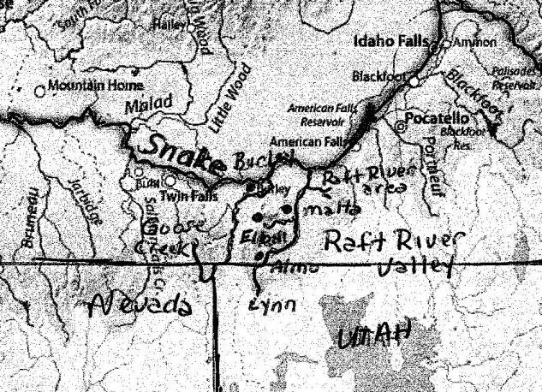
The Raft River Valley is a history rich area. This was truly the “Old West”. In pioneer days, the river and its surrounding valleys and passes played a significant role in the settling of the west. Most early travelers to California and southern Oregon passed this way. To them, this area was an obstacle, at best a curious landmark along the way, marking one step closer to the fertile valleys of the west coast. Even the early trappers found the area challenging. Later the Kelton Road with its mail carriers, stage coaches, freight wagons and cattle drives came through the Raft River area. As years passed, people saw opportunity along the banks of the Raft River and its tributaries and settled here. These are our ancestors. It is their stories that we seek to preserve.

Much of the history is well documented in written journals or general histories. Other stories were passed down in oral histories. We have researched these early years as carefully and thoroughly as possible. We have included many of the writings in the appendices. Our conclusions are opinions based on the study of historical records and our understanding of the area.

We followed the advice Ned Eddins gave us in an email responding to questions we asked him about the travel of an early mountain man and trapper, Joseph Rutherford Walker. Mr. Eddins, creator of “the furtrader.com” website, said:

Trying to pin down the details of someone like Walker is next to impossible. Many sources that try to tell you exactly where Walker went are just blowing smoke, and many of them have never even been in the area he traveled….Living where you do just look around and put yourself in Walker's place and determine what is the easiest route...you won't be far wrong.
As we researched, studied maps and visited local sites, we came to realize that the Raft River Valley was even more significant in the settling of the West than we imagined. Its story began long before our ancestors settled the area. The nature of America and the Raft River Valley began to change at the beginning of the nineteenth century, forming the framework for what would come----each event and each person building upon the foundation of what came before.

The Land of the Snakes

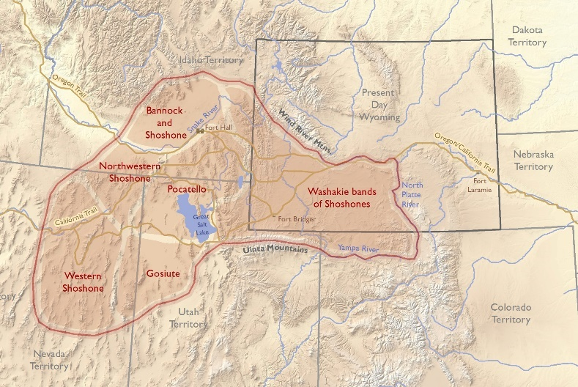
The Raft River Valley was important in the annual migration of the Indians and was known to them as the “place where the snow does not lie.” The early explorers knew the Indians as “Snakes,” lending their name to the Snake River which wound through their territory. The Native Americans in southwestern Idaho called themselves “Newe” meaning “people“. They are most commonly recognized now as Northwestern Shoshoni/Bannock. Historian Leonard Arrington recorded that the two major groups of Indians in Southern Idaho were the Shoshoni and Northern Paiute, with the name “Bannock” being given to a “people of Northern Paiute”. Arrington stated that “by the time the white men arrived in Idaho the so-called Northern Shoshoni and Bannock were for the most part blended into one, most of them speaking both languages. They shared the same region for their villages, and there was some intermarriage between them.” The Northern Paiute neighbored the Northwestern Shoshoni with their lands extending south from Oregon and Idaho into Nevada and eastern California. Sven Liljeblad, a prominent linguist, researcher and author, estimated that there were about 3000 Shoshoni living in Idaho in 1805. The tribes ranged into the adjoining states and no mechanism for a census existed, making it hard to know how many were living in southern Idaho. The various groups were known to each other by their principal food source: bison eaters, mountain sheep eaters, elk eaters, fish eaters, rabbit eaters, pine nut eaters and finally seed eaters. Each group generally traveled throughout their traditional area harvesting various foods for winter’s “time of starvation,” but their principal diet source was symbolic of their level of

affluence. The available natural resources of each region affected their standard of living. Those residing in the Teton mountains lived differently than those living in the alkaline high deserts surrounding the Great Salt Lake. For example, the bison eaters had access to horses enabling them to hunt the nearby buffalo. This gave them a good source of meat, buffalo hides for warmth and leather for clothing. The Indians living along the northern shores of the Salt Lake were often called “Diggers” because they dug along the banks of the lake for small fish and insects or harvested the native roots. They lived in conical, long poled-dwellings thatched with bundles of grass, bark, and tule. Clothing was often made of rabbit fur and leather from small game. There were no “chiefs” but each family group looked up to the most experienced (generally older) men in the group to guide them.

Zenas Leonard, an early mountain man, chronicled his adventures in his book published in 1839. He was the clerk for Joseph Remington Walker’s explorative journey into California in 1833-34. The company traversed the barren lands surrounding the northern edge of the Great Salt Lake. Leonard described the Native Americans they met early in their journey. The “buffaloe country” Leonard described is likely the mountains of the Raft River valley.

On the fourth day of our journey we arrived at the huts of some Bawnack Indians. These Indians appear to live very poor and in the most forlorn condition. They generally make but one visit to the buffaloe country during the year where they remain until they jerk as much meat as their females can lug home on their backs. They then quit the mountains and return to the plains, where they subsist on fish and small game the remainder of the year. They keep no horses, and are always an easy prey for other Indians provided with guns and horses.

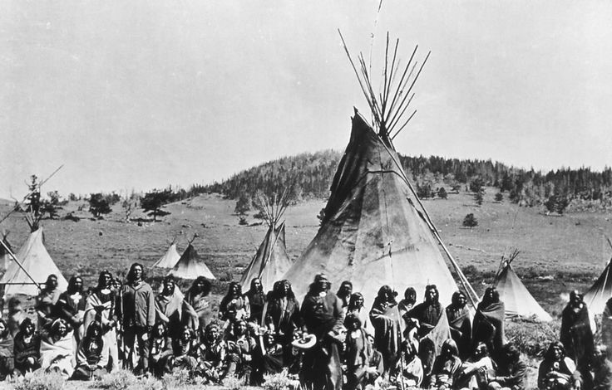
Life became easier in the early 1800’s when the Northwestern Shoshoni obtained horses. The Indians were able to travel farther and more easily. More importantly, they were able to hunt the bison which ranged through the Snake River plain and were also found on the slopes of Mount Independence in the Almo Valley and on the Snowville flat. Some of the Northwestern Shoshoni also hunted on the plains of Wyoming. They began to wear the skin clothing of the plains Indians and live in tipis.

Brigham Madsen who wrote several books about the Northwestern Shoshoni indicated that while the bands traveled throughout their traditional areas as they harvested food for the upcoming year, each group tended to winter in the same spot. Madsen wrote that in the 1850’s,

“Between Bear River and Blue Creek...there was a village of about twenty-three families, with another camp located on upper Blue Creek. Fourteen families wintered at Kelton... and about six families found shelter at Lucin...About twelve families were scattered along Grouse Creek, and a small cluster of six families wintered near Lynn and another eight at Yost with a larger camp stationed on Dove Creek (near Park Valley).

While Madsen made no reference to the Raft River valley concerning winter camps, the valley and surrounding areas were important in the tribes’ annual migration. The tribes had traditional seasonal camp sites at Almo, Connor Creek, Albion, and above Lake Cleveland. The Indians grazed their horses near the City of Rocks during the summer and in the fall, they gathered pine nuts which they ground into flour from the nearby pinyons found in the Castle Rocks. The pinyon trees growing there are the most northern pinyon forest in North America. Pictographs can be seen on one of the marked trails in the Castle Rocks and are reported at other sites throughout the Almo valley. There are several places where Indians sheltered under the protection of overhanging rock ledges. They hunted deer, antelope and buffalo in the area. The meat was jerked for the tribe’s winter meat supply and the hides were tanned and used for everything from clothing to shelter. Winter was a difficult season for the Indians. They spent the entire summer collecting food and preserving it to survive through the winter. The time between the coming of winter and early spring was known as the “Time of Starvation”.

As Zenas Leonard and other mountain men chronicled, marauding Blackfeet, Crow and other raiding parties attacked the Shoshone people, killing and taking prisoners. They often claimed the traditional Shoshone hunting grounds making it dangerous for the Shoshone to venture there to hunt. Nick Wilson, who lived for two years with Chief Washakie’s family, described a terrible battle between Washakie’s band and the Crow Indians in an effort by the Shoshoni to reclaim hunting ground. Chief Pocatello’s mother as a young woman was abducted from along the Raft River by a group of Assiniboin warriors. She heroically managed to escape her captors and return home.

Indians from the Fort Hall Reservation returned to the area to hunt and to gather pine nuts as late as the 1950’s. They would often return to the same camping spots each year and forged relationships with the local families. They would trade beautifully beaded gloves, moccasins and other items to the locals in exchange for their animal hides.

In the years before the settlers, providing food for their families and fending off marauders were the main concerns of the Shoshone people. Just as their lives changed with the introduction of the horse, the coming of the white man brought significant changes to their lifestyle.

Early Explorers

The early explorers set the stage for the development of the North American continent. The captains of the ships would contract with a European nation to sail under their flag. There were generally three objectives for their voyages. The explorers were trying to find the Northwest Passage that would facilitate trade between their sponsoring nation and the Orient. They laid claims to the lands that they encountered and were expected to find ways to bring wealth to their sponsor. For over two hundred years, trapping for beaver was a driving force for the early exploration of North America. There was a lot of money to be made. There was a lot of competition. There was a lot of exploration.

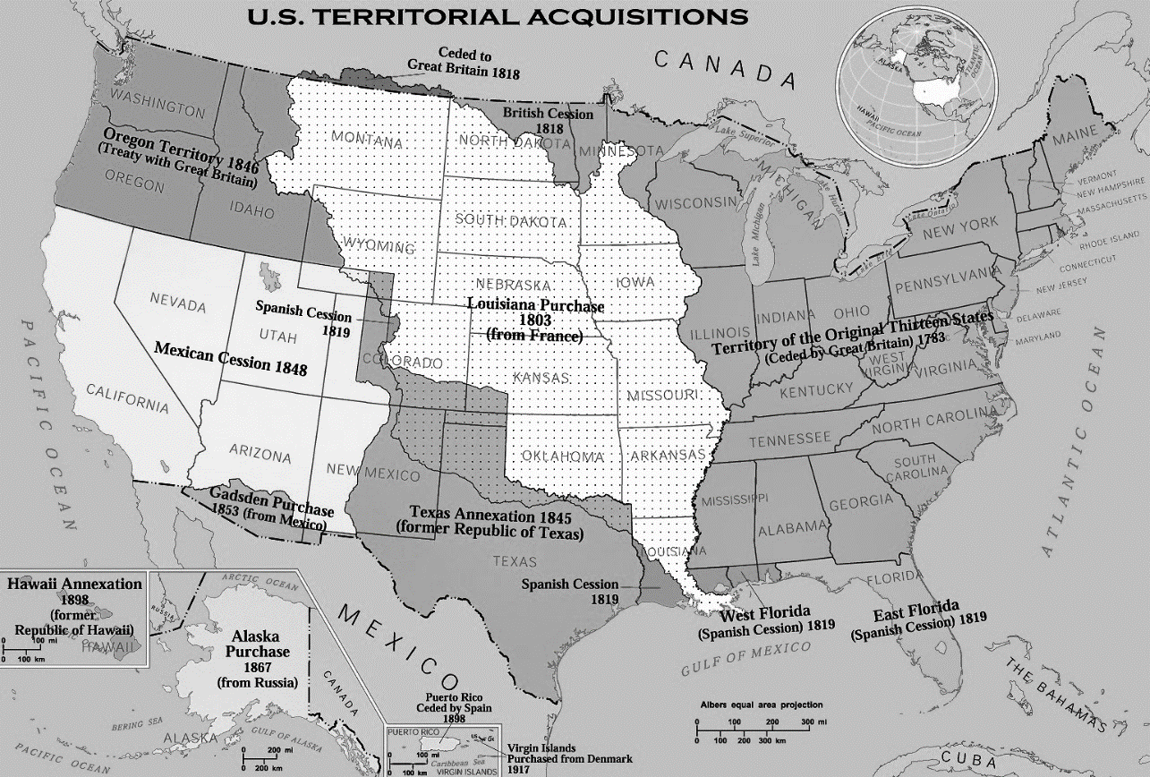

The Spanish had laid claim to Mexico and most of the Southwest in the early 1500’s. Dominquez and Escalante explored through Arizona, New Mexico, Colorado and Utah as far north as Utah Lake in 1766. Their expedition established the Old Spanish Trail and they laid claim to the lands they crossed. The Spanish government did not see trapping as a major source of wealth but instead encouraged explorers to seek out gold and silver. Spanish miners prospected all over the west and Spain and later Mexico held title to the land up to the Idaho/Utah border.
_____________________________
Map: U.S. Territorial Acquisitions (wpclipart.com)
The Vipont Brothers began mining the Vipont Mine near Granite Pass west of the City of Rocks in 1864. Their friend and the author’s ancestor, Eugene Emery Senior, claimed that the brothers were led to the site of the mine by Indians and that it had been worked by early Spanish miners.

Arlo and Stan Lloyd of Elba, Idaho, suggest that they may have found monuments and landmarks in Connor Creek that were described in a book about the Spanish miners that they read years ago. One of the monuments pointed out by the Lloyd Brothers can be seen on a hill to the southwest of the Connor Creek junction. Several suggested that it may have put up by local sheepherders so we decided to get a better look. The sides of the hill are very steep and devoid of any trees. It was hard to get to the top of the hill with a four wheeler. The monument is wide and taller than a man’s head. The thin slabs of rock were gathered from a large area and carefully stacked. Lichen covers the cracks in the rocks. The formation appears very old and is just opposite the Melcher Mine where silver was mined during the early 1900’s. There are three tall monuments on the mountain ridges near the ViPont Mine as well, though we have not made our way up to see them yet.

French explorers had sailed up the St. Lawrence River, laying claims to the surrounding territories. Marquette and Joliet sailed nearly the length of the Mississippi claiming lands on both sides of the river. LaSalle established the French claim on Louisana. The French Canadian trappers were known as Voyageurs and were acknowledged to be the most courageous and hardy of the adventurers. The Voyagers were experienced in wilderness travel and exploration learned through generations of trapping. Other fur companies sought these trappers out to join their expeditions. Trappers from Scotland who immigrated to Canada were also known as highly skilled explorers and mountain men. Alexander MacKenzie and his company made the “first transcontinental crossing of North America above Mexico” in 1793.

British explorers laid claims along the Atlantic coastline and Henry Hudson claimed the land surrounding the Hudson Bay for England. The Hudson Bay Company was established by Great Britain in 1677. Another British trapping company, the North West Company, was formed in 1783, over 100 years later. The two companies competed as they trapped across British holdings in Canada. The hardy French Canadian and Scottish trappers were often included in the British expeditions. Alexander Mackenzie’s party of explorers crossed Canada, reaching the Pacific Ocean in what is now British Columbia in 1793. Their expedition helped establish the British claim on the adjoining lands, including what would become Oregon territory.

The French and Indian War of 1763 changed the nature of North America. Americans saw the war as a local conflict and the event is pretty much overlooked in American history. The war, however, was a precursor to the American Revolutionary War as the colonists increasingly saw themselves as separate from their mother country. For Great Britain and France, it was a world war with battles fought in America, Europe and foreign ports. Just before the end of the war, the French gave their American holdings to Spain in an effort to keep Spain from siding with Great Britain. By 1803, the land had been returned to France and was sold to the newly created United States in the Louisiana Purchase.

The British dealt harshly with the French Canadians after the war. French Acadians were forcibly removed from their lands in eastern coastal Canada and upper Maine by the British as punishment for their role in the British/French conflict. Nearly 12,000 Acadians were dispersed throughout America and several other British holdings with no regard for their well being or keeping family members together. Many were forced into servitude and nearly a third of the people died. Many of these French Canadians ended up in Louisiana where they trapped up the Mississippi River, through the Midwest and into the eastern foothills of the Rocky Mountains, continuing their reputation as voyageurs.

American Expansion

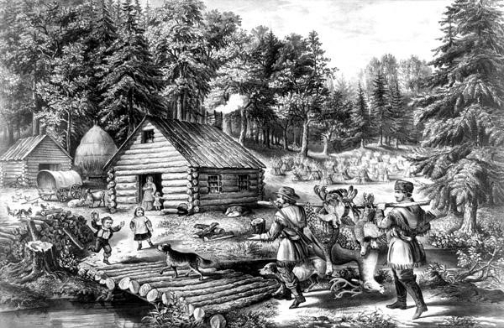
Americans, who had been pushing west since the Pilgrims landed, won the war for independence from England. Many of the soldiers had marched through the unsettled lands of the Midwest in both the French and Indian War of 1763 and the Revolutionary War. Some were paid with bounty land warrants which gave them free land in payment for their military service. Returning home, they packed their few belongings and with relatives and neighbors, headed into the unsettled wilderness.

With the Louisiana Purchase in 1803, the United States owned all the land from the Atlantic Ocean to Spanish California. The dream of Manifest Destiny—or America spanning from coast to coast—was being set into motion and there were many Americans who shared that dream. The British, however, still claimed ownership of the Oregon Territory.

President Jefferson sent Lewis and Clark and their men to explore and document America’s newly acquired lands and hoped they would find a water passage to the Pacific Ocean. They didn’t find the waterway they were looking for, but they found a vast land rich with natural resources and unique wildlife. Immediately upon Lewis and Clark’s return, rugged adventurers headed even further west. Beaver hats were the rage and much money was to be made in the fur trade. In the coming years, powerful fur companies enlisted hundreds of daring men drawn by the lure of the west and the promise of wealth.

The Astorians

American entrepreneur John Jacob Astor was determined not to let the British have control over the lucrative fur trade in the Pacific Northwest. In 1811, he put together two expeditions headed for the mouth of the Columbia River where they were to establish a fort. The first group was sent by the ship, Tonquin. The company consisted of four partners, four craftsmen, and twelve specially chosen Canadian Voyageurs in addition to the twenty six ship’s crew members. Their six month voyage took them around the tip of South America with a stop in the Hawaiian Islands to resupply. Twelve Hawaiians joined their venture with more to come later. Three Hawaiian trappers later explored---and mysteriously disappeared—in south western Idaho. The Owyhee River –originally called the Sandwich Island River—was named after them.

The captain of the Tonquin was a harsh man whose leadership and judgment created frequent conflict with the Astorians. Eight men were drowned after being ordered against their will to find a way through the rough waters at the mouth of the Columbia River in a small whale boat. The ship was finally able to find a passage through the rough waters and make harbor. The explorers disembarked and began their work of building the fort, naming their small settlement Astoria, after their benefactor, John Jacob Astor. The captain and crew began their journey home. The ship anchored on the west side of Vancouver Island where they hoped to trade with the local Indians. The ship’s captain, a very stern and unbending man, argued with one of the leading Indians, slapping him in the face with a sea otter pelt in a disagreement over terms of trade.

The next day, several canoe loads of Indians boarded the ship to trade. The crewmen, sensing danger, became frightened and ordered the Indians to leave. The Indians drew their hidden weapons from under their blankets and killed all but two of the crew. The next day when the Indians returned, the last surviving trader who had been severely wounded lit the powder magazine, killing himself and nearly 200 Indians. Only an Indian interpreter survived to tell the Astorians what had happened to the ship and its crew.

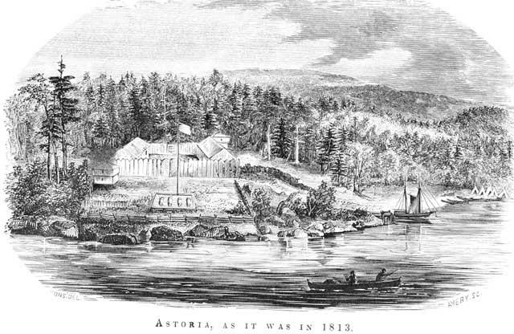
The second expedition traveled overland and was headed by Wilson Price Hunt, a businessman with no wilderness experience. He had, however, also engaged Canadian voyageurs, frontiersmen who had spent much time trapping and exploring in the Canadian wilderness. Pierre Dorian, part French Canadian and Indian, signed on as an interpreter and was accompanied by his wife, Marie, also part Indian and French Canadian. Their little boys were two and four years old. Marie was expecting a baby in a few months. Along the way, Hunt met a group of returning trappers who told him of an overland route into the Jackson Hole and Henry’s Fork areas. Hunt decided to take that route instead of following Lewis and Clark’s trail up the Missouri tributaries. It was a tragic venture, filled with suffering and loss.

In September 1811, the company reached Henry’s Fork on the Snake River. The men believed the Snake River was the elusive waterway that would take them to the Pacific Ocean. Its headwaters are only a short portage across a fairly low pass from the headwaters of the Missouri on the eastern side of the divide. Unlike the Missouri River, however, the Snake and Columbia Rivers are treacherous and deadly.

The Astorians left their horses in the care of local Indians, loaded their supplies into several canoes they had hollowed from large cottonwood trees and set out on the next stage of their journey. Their course down the river proved challenging. The men were forced several times to portage around rapids and falls. Washington Irving chronicled their trip in his 1836 book, Astoria, which was written from the letters and other records of the explorers. Irving wrote:

The spirits of the party, however, which had been elated on the first varying their journeying from land to water, had now lost some of their buoyancy. Everything ahead was wrapped in uncertainty. They knew nothing of the river on which they were floating. It had never been navigated by a white man, nor could they meet with an Indian to give them any information concerning it. It kept on its course through a vast wilderness of silent and apparently uninhabited mountains, without a savage wigwam upon its banks, or bark upon its waters. The difficulties and perils they had already passed made them apprehend others before them, that might effectually bar their progress.

The voyageurs traveled nearly three hundred miles on the Snake past Fort Henry before they began to come in late October upon occasional small groups of tents along the river. They would have been somewhere between the joining of the Raft River with the Snake River and the city of Burley. The weary men hoped to gain some information about the country which lay ahead and to reprovision their dwindling supplies. The Indians, never having seen a white man, fled in terror, leaving their villages deserted. Irving described a touching account when one brave Shoshoni man returned to his camp to confront the explorers. His family and the other villagers depended upon their carefully preserved stores of meat and fish to get them through the winter---the “time of starvation.” Washington Irving recorded:

At length one, who was on horseback, ventured back with fear and trembling. He was better clad and in better condition, than most of his vagrant tribe that Mr. Hunt had yet seen. The chief object of his return appeared to be to intercede for a quantity of dried meat and salmon trout, which he had left behind: on which, probably, he depended for his winter’s subsistence. The poor wretch approached with hesitation, the alternate dread of famine and of white men operating upon his mind. He made the most abject signs, imploring Mr. Hunt not to carry off his food. The latter tried in every way to reassure him, and offered him knives in exchange for his provisions; great as was the temptation, the poor Snake could only prevail upon himself to spare a part; keeping a feverish watch over the rest, lest it should be taken away. It was in vain Mr. Hunt made inquiries of him concerning his route, and the course of the river.

The voyageurs left the Indian camp, launching their rough hewn canoes again into the currents of the Snake River. They had no idea of the treacherous rapids and dangerous falls that lay ahead. The explorers had encountered the Idaho Falls and American Falls but were able to portage around them with little difficulty. Now entering the deep canyon of the Snake River near Twin Falls, they came to the first of the three falls in the canyon: Caldron Linn near Murtaugh, followed by Shoshone Falls and Twin Falls.

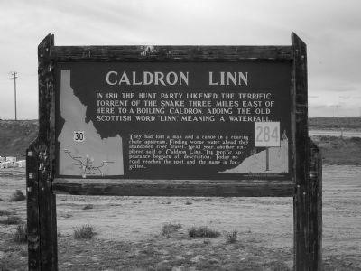
We visited the Caldron Linn for the first time in April 2013. To stand on the banks above the Caldron Linn, one marvels that anyone survived the Astorians’ encounter. It is a truly terrifying sight to see the river come around the curve and drop into a huge hole, the water churning as if in a huge boiling caldron, and then turn into a series of rapids and very swift moving water. The vertical walls on both sides of the river leave no way out, Upon entering the Caldron Linn, one is at the mercy of the river. Even modern day adventurers in specially equipped crafts have not survived its passage.

The road marker on the old Highway 30 between Burley and Twin Falls reads: “In 1811 the Hunt party likened the terrific torrent of the Snake River three miles east of here to a boiling caldron, adding the old Scottish word “linn,” meaning a waterfall…Next year, another explorer said of Caldron Linn, “Its terrific appearance beggars all description.”

Washington Irving wrote of their experience, which occurred shortly after their encounter with the Indian man:

In the course of that and the next day they made nearly eight miles; the river inclined to the south of west, and being clear and beautiful, nearly half a mile in width, with many populous communities of the beaver along its banks. The 29th of October, however, was a day of disaster. The river again became rough and impetuous, and was chafed and broken by numerous rapids. These grew more and more dangerous, and the utmost skill was required to steer among them. Mr. Crooks was seated in the second canoe of the squadron, and had an old experienced Canadian for steersman, named Antoine Clappine, one of the most valuable of the voyageurs. The leading canoe had glided safely among the turbulent and roaring surges, but in following it, Mr. Crooks perceived that his canoe was bearing towards a rock. He called out to the steersman, but his warning word was either unheard or unheeded. In the next moment they struck upon the rock. The canoe was split and overturned. There were five persons on board. Mr. Crooks and one of the companions were thrown amidst roaring breakers and a whirling current, but succeeded, by strong swimming, to reach the shore. Clappine and two others clung to the shattered bark, and drifted with it to a rock. The wreck struck the rock with one end, and swinging around, flung poor Clappine off into the raging stream, which swept him away, and he perished. His comrades succeeded in getting upon the rock, from whence they were afterwards taken off.

This disastrous event brought the whole squadron to a halt, and struck a chill into every bosom. Indeed they had arrived at a terrific strait, that forbade all further progress in the canoes, and dismayed the most experienced voyageur. The whole body of the river was compressed into a space of less than thirty feet in width, between two ledges of rocks, upwards of two hundred feet high, and formed a whirling and tumultuous vortex, so frightfully agitated as to receive the name of “The Caldron Linn”. Beyond this fearful abyss, the river kept raging and roaring on, until lost to sight among impending precipices.

The survivors managed to pull themselves out of the Caldron and made camp on the shore. Their situation was desperate. It was nearly the first of November. Winter was upon them. They had no idea where they were or how far it was to their destination. Many of their supplies had been destroyed in the swirling rapids. The next morning, scouts set out on foot on both sides of the river, hoping to find the end of the rapids. One of the groups determined that they might be able to return to the river and carried four heavy canoes and their supplies and gear several miles downstream. All four canoes and the supplies were lost to the currents as they attempted to again navigate the river. The voyageurs reluctantly realized that they would not be able to travel by water any further.
Three groups were sent out on rescue missions while the main camp of about thirty remained near Caldron Linn; two—one on each side of the river-- hoped to make contact with Indians and trade for supplies and find out some information about the route ahead. The third group attempted to return to Fort Henry, hoping to retrieve their horses. Those men returned shortly, realizing that they were too far from Fort Henry and that the winter weather would not allow them to make the journey.
According to Irving, Hunt could see no other option than to divide the party into two groups. He sent one group on each side of the river, hoping that some of them might eventually make it to the mouth of the Columbia River where they were to meet with the voyageurs who had come by sea. It is more probable that the real reason the explorers scouted on each side of the river is that as they pulled themselves from the swirling waters, they were unable to join their comrades on the opposite bank. They couldn’t cross the waters of the Caldron Linn. The lava cliffs surrounding the narrow river canyon tower hundreds of feet high on both sides of the river for miles. Attempts to cross the river downstream had resulted in the loss of canoes and supplies. They likely signaled each other across the raging river and headed the best they could for the mouth of the river, still hundreds of miles away across unknown territory .

Each person had to pack his gun and other gear in addition to the meager food supplies. The eleven who found themselves on the north side of the river made their way into present-day northern Idaho and along Hell’s Canyon. This group included Maria Dorion and her two young children. Her baby was born along the way but only lived a few days. The explorers fell in with a band of Nez Perce Indians who fed them through the winter and then sold them canoes to continue their journey. That group arrived at Astoria by way of the Snake and Columbia Rivers in January 1812. In February, Hunt and thirty-three others reached Fort Astoria after taking a route through the harsh country of central Oregon. One of the leaders, Ramsey Crooks became so ill that couldn’t go any further. John Day offered to stay with him and the two of them wintered in southwestern Oregon, facing not only starvation but attacks by Indians. An Oregon town, river and several monuments bear the name of John Day. The last of the group finally made it to Fort Astoria that fall.

Robert Stuart, one of the men who had come by sea, was immediately assigned to take a company of men back to Missouri with messages for Astor. They blazed the trail which would later be rediscovered as the South Pass, the main route of the pioneers.

Upon learning of the American presence at Fort Astoria, the leaders of the North West Company sent one of their chief trappers, a Scotsman named David Thompson, to do damage control along the Columbia River. Thompson and his trappers were the first white men to follow the Columbia River to the Pacific Ocean. His men established forts or trading posts in Montana, Idaho, and Oregon before showing at Fort Astoria “to visit” for several days. When the first trappers out of Astoria traveled up the Columbia River, the Astorians were angered to discover signs posting the river as being claimed by Britain.

The War of 1812 prompted the Americans to sell Fort Astoria to the British fur companies without consulting Astor and other owners of the Pacific Fur Company. The local partners sensed that it was inevitable that they would lose the fort. The timing was good because a short time later, a British man-of-war sailed into the harbor with orders to take the fort.. The sale of Astoria established British dominance in the Oregon Territory and gave the British and Canadian trappers a solid local base of operations.

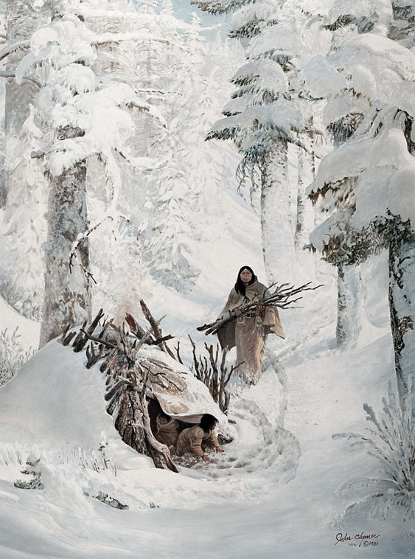
Marie Dorian is honored by a monument just outside a replica of Fort Boise near Parma, Idaho. In 1814, Pierre Dorian and several other trappers were trapping along the Boise River. Marie and their two little boys were at a trading outpost when she learned that a group of Bannock Indians were planning an attack on the trappers. She and her young sons traveled three days through snow to warn her husband. When Marie reached the trappers, she found them all dead but one. She nursed him throughout the day, but the man also died. She returned to the trading post, only to find everyone there had been killed as well. Marie gathered some abandoned horses and attempted to reach a distant trading post. For fifty days during harsh winter conditions, she provided for her children. She killed one of the horses, smoking the meat. She also made snares with hair from the horse’s mane and trapped rabbits. She gathered frozen blackberries and harvested pulp from the inside of trees. The mother and her children eventually reached a Walla Walla village where they were cared for. The next spring the family was able to reach the fort when trappers floating the river heard Marie’s two young children who were playing with their friends, call out to them in French. The trappers took Marie and her boys back to Fort Astoria.
Setting the Stage
Several important developments occurred in the early 1820’s that shaped the trapping and exploration in the Raft River Valley. Because they were facing increased competition in trapping from other countries, the British government revoked the license of the North West Company, leaving the Hudson Bay Company as the only British trapping company. The British trappers headquartered along the Columbia River, establishing a series of forts or trading posts throughout the Columbia Basin beginning with Fort Astoria. They used these posts as their bases of operation and resupply. Their men trapped the Snake River Basin and into the Great Basin in Utah. The British actively trapped in the Raft River Valley several times.
American trapper, Andrew Henry, who had established a fort and trading post before 1811 at Henry’s Fork in eastern Idaho, partnered with William Ashley and others to form the Rocky Mountain Fur Company in 1822. The Rocky Mountain Fur Company operated out of St. Louis.
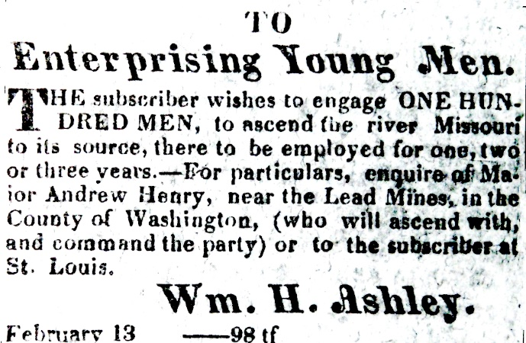
Ashley posted an advertisement in the St. Louis newspapers for a hundred “enterprising young men… to ascend the river Missouri to its source, there to be employed for one, two, or three years.” The men who answered Ashley’s ad became known as “Ashley’s Hundred”. Ashley’s Hundred, the Astorians and the men who accompanied Lewis and Clark made up a “who’s who” of mountain men. There isn’t a full or verified list of the hundred men, but they seem to have included Jim Beckwourth, Thomas Fitzpatrick, Jim Bridger, William Sublette, John Weber, and Jedediah Smith. All of these men became well known mountain men and explorers.

Probably the biggest change came with Mexico winning its independence from Spain in 1821after nearly a hundred years of ongoing confrontations. The Spanish government had encouraged exploration for gold and silver but had no interest in furs or trapping. They had two goals. One was to convert the Indians to Christianity. The other was to find gold and silver.

The Spanish were very protective of their land claims. They were afraid that the American and French trappers who ventured into Spanish Territory would be tempted to mine the precious minerals and weaken the Spanish Claim on the land. Any foreigner venturing into their lands was arrested and taken to Taos, New Mexico, or sometimes as far as Chihuahua for questioning and frequently imprisoned. Several trappers were held for up to twenty years. Others were released after a short imprisonment and a stern warning.

In 1821, the Mexicans obtained their independence from Spain and the new government removed restrictions on trade. Americans began to establish the Santa Fe Trail from Missouri to Santa Fe in order to capitalize on trade with New Mexico. The new Mexican nation was eager for trade goods that had been severely limited by the Spanish government. The news of their independence spread slowly and many citizens did not realized what had happened. One group of Indians had been charged by the Spanish government not to let any foreigners into their lands. The Indians were preparing to attack a group of American trappers who had come into their territory when they received word to let them proceed.

American and French Canadian trappers began coming into the New Mexico territory, this time without fear of imprisonment. Many of those trappers had been taken prisoner multiple times as they had attempted to sneak into the Spanish territory. Taos, New Mexico, became the headquarters of these trappers who worked independently, without any established fur companies. There were very few Mexican trappers because of the restrictions that had been put into place by the Spanish government. Many of the licenses issued to the Americans and the French required that they employ Mexicans as a means of training them.

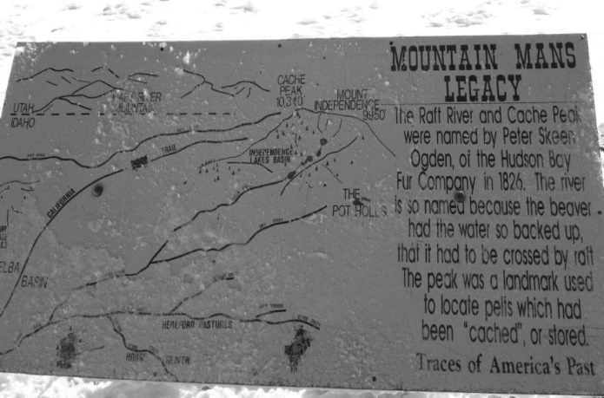
A study of those trapping expeditions gave us a new perspective on the early trappers and their contribution to the story of the west. We assumed that the trappers spent their time on the larger Columbia and Snake Rivers. Now we realize that the deep and fast flowing rivers would not have been conducive to beaver. Beaver were found on the tributaries where they could dam the streams and build their lodges in the deep and slow moving water behind the dams. The realization that the early trappers were following tributaries to their headwaters changed our perception of their travels in the area. The trapping season was from about the first of November until the first of June. The life of a trapper was not an easy one as they crossed mountain ranges and trapped the streams in the middle of winter. As American, English and French fur trappers followed the beaver, they explored the Rocky Mountains, the Tetons, the Snake River plains, Cache Valley, the Great Basin, the Raft River and adjoining valleys. Cache Peak and Mount Harrison were prominent landmarks since they could be seen from a long distance in several directions. The Raft River is mentioned in the journals of many of the early trappers. Later travelers recorded that the Raft River in the Malta valley was dammed by the beaver so that the river was a swamp over a mile wide and difficult to cross.

By the early 1820’s, there were three main bases of resupply for the trappers: The British had been trapping across Canada and were now centered in Oregon Territory, resupplying from their forts along the Columbia River. The French trappers had been trapping out of New Orleans, their main hold in American after the French Acadians had been displaced from Canada and then their lands sold through the Louisiana Purchase. They had been trapping the Mississippi River or trying to sneak into Spanish territory for years. Now they and a few American trappers headquartered in Taos, New Mexico. The Americans, headquartered in St. Louis, had been trapping the Missouri River and expanded into the Yellowstone region and around Henry’s Lake. Changing circumstances required them to find new trapping grounds. By the 1824-1825 trapping seasons, all attention was focused the Snake River Basin and the Great Basin in Utah.

The Snake River and Great Basin Expedition

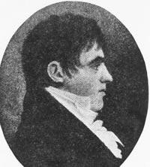
Peter Skene Ogden was born to wealthy Tory parents who fled the United States to live in Canada after the Revolutionary War. His parents hoped to train him for the law, but Ogden chose the life of an explorer and trapper. He learned languages easily and spoke English, French, and several Indian dialects. In his youth, Ogden had a violent temper and was involved in the death of an Indian trapper. The Hudson Bay fur company tried to control Ogden by sending him to the far west. He proved himself by leading the Snake River Brigade on six expeditions. Ogden was just thirty years old and described as “short, dark, and exceedingly tough” when he assumed command of the Brigade. Ogden’s first expedition took him to the Great Basin in Utah. William Kittson, a member of the brigade, described the 1824-25 company.

The party is now together consisting of 22 lodges which contain besides Mr. Ogden and myself, Charles McKay an interpreter of the Piegan Language (a Blackfoot tribe) 10 Engages 53 fremen and lads, 30 Women and 35 Children, all well furnished in arms ammunition Horses and Traps, able in all appearances to face any War party brought into the plains.
Alexander Ross and his men trapped along the Snake River the winter of 1823-1824. Ross, a Scot immigrant to Canada, had signed on with the Astorians as a clerk and had accompanied the group of voyageurs who had gone by ship to the Columbia River. After Fort Astoria was sold to the British, he joined the North West Company and on its dissolution, joined Ogden’s Brigade. Alexander Ross’s British trappers claimed to have camped near the City of Rocks on August 24, 1824, but found the number of beaver disappointing. Some experts question Ross’s reports because he wrote his memoirs in his old age and some of the details and dates don’t correspond. They don’t question that his trappers were in the area, but question the timing of some of the events. His apparent encounter with a group of Indians while on this trapping expedition had serious consequences.
A group of American trappers under Thomas Fitzpatrick and employed by the Rocky Mountain Fur Company out of Saint Louis were exploring the Cache Valley and Ogden area the season of 1823-1824. Jim Bridger who was then 20 years old, was with a group of men who floated the 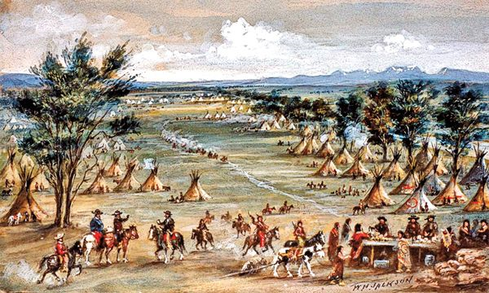Bear River to see where it ended. The Bear River turned out to be a tributary of the Great Salt Lake. Bridger apparently thought at first that they had discovered the Pacific Ocean. For years, Bridger’s party was credited with discovering the Great Salt Lake but it now is generally acknowledged that French Canadian trapper Etienne Provost and his men were the first white men to see the Lake. Now we wonder if the Spanish gold seekers may have seen the Salt Lake much earlier. Bridger and his men apparently didn’t trap in the Great Basin at that time but returned to report their discovery to Tom Fitzpatrick. Nearly twenty years later, Fitzpatrick used the information garnered by Bridger’s group to advise the Bidwell/Bartleson wagon train as they headed to California.
Fitzpatrick and several other prominent mountain men had crossed the Continental Divide during that winter under horrific conditions. The wind blew so hard for several days that they had to stay awake to keep their blankets and buffalo robes from blowing off their bodies. On their return to St. Louis, they were able to report the rediscovery of the South Pass which enabled easier passage to the western rivers and their rich store of beaver.

The information provided to William Ashley by Fitzpatrick and Bridger opened up a new trapping venue for the Americans. The Rocky Mountain Fur Company had been traveling up the Missouri River to its headwaters in Montana, crossing the divide and trapping near Henry’s Lake and into Yellowstone. Andrew Henry had explored that area and set up a trading post there many years earlier. Ashley and Henry lost several men in a battle with the Arikara Indians near the Grand River and felt it was unsafe to continue taking that route. Their fur company was heavily in debt and on the verge of failure. A new pathway to profitable trapping grounds was welcome news and their trappers headed for the Great Basin.

Etienne Provost (pronounced Pre-vo in French) was an enterprising French Canadian trapper who had been imprisoned by the Spanish at least twice. After learning that the Mexican government was allowing trappers into their country, he began to put together a company of trappers and was licensed by the Mexican government and headquartered out of Taos. During the winter season of 1823-24, he and a group of about 15 men set up camp near the mouth of the Jordan River, known originally as the Provost River. Provost’s party encountered a group of Indians there. In his book, Life in the Rocky Mountains Warren Angus Ferris described their experience.

There is one evil genius among them, called the “Bad Gocha,” (mauvais gauche—bad left-handed one) who fell in with a party of trappers, led by a well-known mountaineer, Mr. E. Proveau, on a stream flowing into the Big Lake that now bears his name, several years since. He invited the whites to smoke the calumet of peace with him, but insisted that it was contrary to his medicine to have any metallic near while smoking. Proveau, knowing the superstitious whims of the Indians, did not hesitate to set aside his arms, and allow his men to follow his example; they then formed a circle by sitting indiscriminately in a ring, and commenced the ceremony; during which, at a preconcerted signal, the Indians fell upon them, and commenced the work of slaughter with their knives, which they had concealed under their robes and blankets. Proveau, a very athletic man, with difficulty extricated himself from them, and with three or four others, alike fortunate, succeeded in making his escape; the remainder of the party of fifteen were all massacred.. The survivors made their way northeast over the Wasatch range.
The following season -1825- Provost and his party met Peter Skene Ogden and members of his Hudson’s Bay Company trapping party on the Weber River, near present-day Mountain Green. Upon hearing the story of Provost’s narrow escape, Ogden wrote his superiors that he believed that the attack on Provost and his party had been instigated by Alexander Ross and his Hudson Bay party who had been trapping in the Snake River the year before—not far from where Provost was attacked. They had stolen some horses from the Indians, killing one of the Indian men. Ogden surmised that incident caused Bad Gocha’s attack on Provost.
The next season, Ogden and Provost’s men were trapping amiably on the Weber and Ogden River when a group of American trappers showed up. Their encounter intensified Ogden’s hatred of the Americans. A modern day writer on the website, Mountain Men and life in the Rocky Mountain West , wrote:
On May 23, 1825, twenty-five trappers flying an American Flag paraded to within 100 yards of Ogden ’s camp, where they laid out their own camp. As night fell, Johnson Gardner paid a visit to Peter Ogden and his clerk, William Kittson. Gardner proclaimed that the British were trespassing on U.S. territory and must leave at once. Gardner also declared that the Americans were ready to offer any of Ogden’s men who chose to desert $3.50 per pound for their beaver, and would provide supplies at lower costs than those available from the Hudson’s Bay Company. Furthermore, the Americans would fight to defend any who decided to change sides.
Gardner again returned the next morning. “Do you know in whose country you are?” he demanded. Ogden replied that he did not, that possession of the Oregon Country had not been resolved. “Wrong” countered Gardner, “it belongs to the United States” and Ogden must leave at once! Ogden was firm, he wouldn’t leave until he received instructions from his superiors.
Ironically, this heated discussion was being held in what was then the territory of Mexico. (Provost, who was camped nearby and likely watching the encounter was the only one who actually had a license from the Mexican Government).
Although Ogden wouldn’t back down on the issue of territory, he did retreat to Flathead Post after the defection of 23 of his free trappers and 2 engagés and the loss of all their furs and equipment. Proximity to the Americans had been just too enticing and Ogden feared losing even more men (and their furs) should he remain.
Provost trapped with the Americans for a while, then retired to St. Louis. When Brigham Young later sent settlers south along the river, the people were informed by an old mountain man that the river and canyon were the Proveau River and Canyon. The Mormon settlers retained that name for their settlement. One of the authors suggested that Provost was still alive at the time and had no knowledge that the new town, Provo, was named in his honor.

Ogden’s Snake River Brigade

Ogden’s second expedition left Fort Vancouver (near Portland) in November 1825. Ogden engaged a Snake Indian scout in order to make easier time through the unknown territory. The brigade ascended the John Day River into central Oregon. They crossed over to the Powder, Burnt and Malheur (Unfortunate) Rivers before coming onto the Sandwich Island (Owyhee) River in southeastern Oregon. The journey was a terrible ordeal. The snow lay deep. Game was scarce. The company neared starvation, even after butchering many of their precious horses for food. Ogden left 14 men and the weakest horses to trap the Owyhee and arranged a rendezvous on his return in July.

Early in March, the company camped along the Malad River near the Hagerman valley in Idaho and on March 20th, they reached the Raft River. A group of thirty Indians visited the camp and reported that a party of Americans and Iroquois were camped about three days away. Ogden feared that the Americans might lure away his trappers again. He was relieved that none of the men deserted the brigade. The activities of the Snake Indians intrigued Ogden. He recorded:

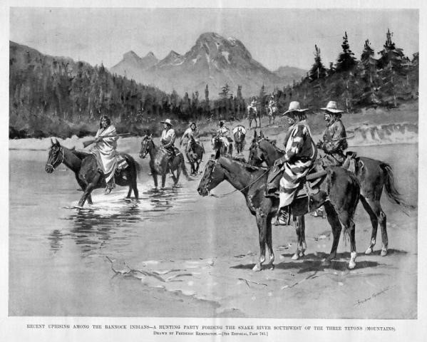
”The stream is lined with Snake Indians preparing to descend to avoid the Blackfeet Indians….The Snake camp began to move about sunrise and continued passing till night; not less than 400 heads, nearly double that number of horses. This camp is bound to Sickly (Malad) River for roots and salmon. In the fall they will return to winter in the Buffalo plain. This is the life they lead. The Blackfeet are fast diminishing their numbers and before many years all will be killed.”

Several more large groups of Snakes passed by in the next few days. The trappers spent four days trapping along the Raft River before moving on to their destination on the Portneuf River. They passed the American Falls on their way.

Places are generally named after a person or event important in that area. The Portneuf River was named after a trapper killed along its banks. A group of American trappers was swept over the American Falls. Only one man survived.

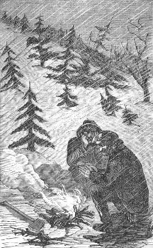
Ogden encountered several bands of Blackfeet Indians and was constantly on guard against these aggressive natives. One of the Piegan Blackfeet Chiefs warned the trappers that they could not be “too much on guard” for they were surrounded by war parties. The next day, the Piegans set fire to the plains with the intent to kill or drive the trappers out. The company left the Portneuf and reached the Raft River on the 6th of May. A spring snowstorm hit. Ogden recorded that “many of the trappers…almost froze, naked as the greater part are, and destitute of shoes…Two thirds without a blanket or shelter”. Half the camp became ill after eating beaver that had fed on poisonous roots.

It is significant that the Indians informed Ogden that a “party of Americans, about 30 in number, has descended this stream on their return from Salt Lake.” ³⁰ As early as 1826, mountain men traveled across the Snowville flats, crossed the Kelton or Strevell Pass and followed the Raft River to its mouth on the Snake.

Ogden’s brigade is credited with the discovery of Granite Pass on June 11, 1826, though the discovery is not specifically described in Ogden’s journal. One author surmised that Ogden was “unimpressed” by his discovery of Granite Pass since he was looking for beaver and not for overland wagon routes and Granite Pass was just one of countless passes he had traveled.

Ogden’s journal entries between May 6th and June 11th do not provide any clues as to the whereabouts of the Snake River Brigade. His infrequent writings describe only his interactions with several small groups of Snake Indians. It does appear that after the brigade was driven from the Portneuf River, they trapped along the Raft River for over a month. The Hudson Bay Company’s directive was for Ogden to trap the streams of the Snake River plains to extinction in an effort to discourage the American trappers from coming into the area. The men very likely trapped along Cassia Creek and Almo Creek and possibly into the Albion Valley during this trip.

After leaving the Raft River, Ogden headed for the Owyhee River, worried about the fate of the fourteen men whom he had left on the river in February. The company retraced their journey up the Sandwich Island River, Burnt River and the Day River, finally reaching Fort Vancouver a little over a month after crossing Granite Pass. Part of the fourteen men had already returned to the fort with their pelts and the rest eventually made it back as well.

Ogden’s 1828-29 Snake River Brigade followed the rivers south through central Oregon and came to what Ogden called the “Unknown River”. He thought it was a fork of the Sandwich Island River but the brigade had actually discovered the Humboldt River which the early travelers called either Ogden’s River or Mary’s River. Turning east, the brigade passed near Lucin and Park Valley, Utah. They camped at Ten Mile Spring on the southeast slopes of the Clear Creek Mountains. The trappers got their first view of the Great Salt Lake from this camp ground.

Stan Lloyd, well driller and amateur geologist and historian from Elba, states that the 1934 Park Valley earthquake caused the ground to shift upward about two feet and pushed the Salt Lake back some distance. The marshy ground which surrounds the Salt Lake was more visible from the Clear Creek mountains in Ogden’s day.

The Snake River Brigade spent the season trapping along the Bear River through Cache Valley and along the Wasatch Front. They returned to Ten Mile Spring and then retraced their path back to the Columbia River. The company trapped the lower Raft River Valley that year as well, but did not feel it was profitable to go further up the river. The brigade likely crossed the Kelton Pass into the Malta valley as they were camped at Ten Mile Springs.

John Work in the Raft River Valley

John Work, Ogden’s successor, brought his men back to the area in 1831. The trappers left their camp on the Portneuf River near Pocatello, Idaho, and stopped to trap for two days along Rock Creek, south of American Falls. The weather was cold and stormy as they headed for the Snake River. Snow still lay in the mountains and the grass had barely begun to grow. The road had been “very hilly” and the horses were “much fatigued”. After a short rest, the Brigade cut across country towards the Raft River. John Work’s journal contains an interesting and detailed description of the Raft River Valley.
Wednesday, May 4th. Cloudy, stormy weather. Marched 10 miles W. S. W. to Raft river which we fell upon 10 or 15 miles from its junction with Snake river. The road good but very hilly the forepart of the journey. Raft river is now very
high and muddy owing to the melting of the snow. There are some appearance of beaver in it though this part of it was hunted by the Americans last fall…. Some tracks of buffalo were seen on the opposite side of Snake river, and the tracks of some herds ascending the river. We have, if possible, to procure a stock of provisions as we have a long way to march through a country nearly destitute of animals of any kind, and this is the last place where we are likely to find any buffalo. (Possibly the Idahome area.)
Thursday, May 5th. …Marched 5 miles south up the river, when we encamped, and sent the most of the people after a large herd of buffalo which was discovered feeding in the mountain….(possibly near Malta. The buffalo may have been feeding at McClendon Springs.)
Saturday, May 7th. Marched 12 miles south up the river. It is fortunate we find buffalo here as it saves us the trouble of going a long day's march to the Eastward, to a place out into the plains called the Fountain where buffalo are always said to be found. It would lose at least three days going to this plain. (Bridge area, with the Snowville Flats being the “plains”. Fountain could be Pilot Springs)
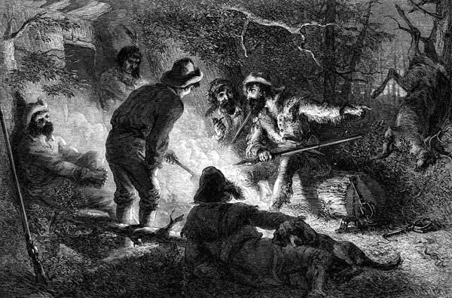
Sunday, May 8th. …Marched 12 miles south up the river. The road still good, but grass for the horses very indifferent. A number of the people went in pursuit of a large herd of buffalo which was feeding on the opposite shore of the river, and killed a number of them, the meat of which is now being dried. Blackfeet are still following our camp. Two of the young men, who went out into the plain yesterday to discover buffalo, saw them, but were not sure, on account of the haze, whether it was men or antelopes. Two of the men who went back this morning for some traps which they had (left) behind saw the Indians coming to our camp after all the people had left it some time. (Through the Narrows into the Almo Valley.)

Monday, May 9th. Fine weather. Did not move camp in order to give the people time to kill some more buffalo. Some large herds were found at the foot of the mountains on this side of the river, a number of whom were killed (Almo Valley).
Tuesday, May 10th.. Raised camp, and proceeded 10 miles south up the river, the Roche, where it becomes confined in a narrow valley. (Between Almo and Lynn)
Wednesday, May 11th…Marched 10 miles S. S. W. up the river, the road good. (Lynn).
Thursday, May 12th. Fine weather in the morning, but heavy rain and snow and very cold afterwards. Raised camp and marched 10 miles across the mountains, and encamped on a small rivulet of snow water. The head of Raft river appears in a deep valley
to the west of us. The road on the mountains hilly and rugged and some places stony, and in places very boggy….For want of water we could not encamp sooner. (Over Granite Pass. The deep valley is likely the Cotton Thomas Basin).
Work then recorded:
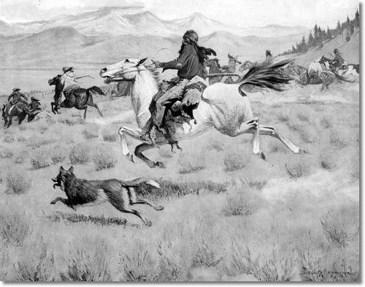
In order that we may make a better (?) I separated a party this morning and sent 8 men… to hunt to the Westward on the heads of small rivers which run into Snake river and on the Eastern fork of Sandwich Island River (Owyhee), while I with the remainder of the party proceed to the southward to Ogden's river (Humboldt), and then to the head of Sandwich Island river….(later they) camped on Mr. Ogden’s usual road to Ogden’s River.

The Rendezvous

Moving the furs and resupplying the trappers was a huge challenge for the owners of the fur companies. The British trappers operated out of forts located on the Columbia River. Trappers licensed to trap in Mexican territory sold their furs and resupplied in Taos, New
Mexico. American trappers headquartered in St. Louis. From 1825 to 1840, the owners of the fur companies held large rendezvous where the mountain men could sell their pelts and resupply. Many Indians attended as well. Mountain man Samuel Parker recorded:

The American Fur Company have between two and three hundred men constantly in and about the mountains engaged in trading, hunting and trapping. These all assemble at rendezvous upon the arrival of the caravan, bring in their furs and take new supplies for the coming year, of clothing ammunition and goods for trade with the Indians.
Another mountain man, James Beckwourth, wrote:
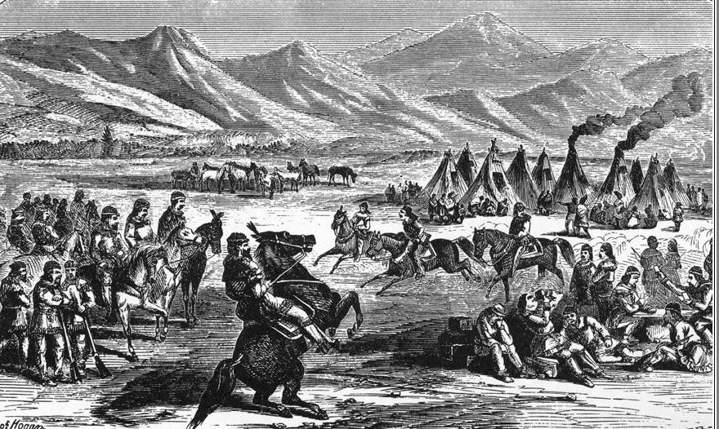
It may well be supposed that the arrival of such a vast amount of luxuries from the East did not pass off without a general celebration. Mirth, song, dancing, shooting, trading, running, jumping, singing, racing, target-shooting, yarns, frolic, with all sort of extravagances that white men or Indians could invent were freely indulged in. The unpacking of the medicine water contributed not a little to the heightening of our festivities.

Many of the American trappers were educated entrepreneurs. New fur companies were frequently formed and reformed. Some were cutthroat in their competition both for furs and to sell their supplies to the trappers. Men would defect from one company to enlist in another. They brought their knowledge of the various parts of the country with them.
Several characters important in the exploration of the Raft River valley emerged from the Rendezvous. They include the Sublette Brothers, Tom “Broken Hand” Fitzpatrick, Captain Benjamin Bonneville, Joseph Rutherford Walker and Zenas Leonard. While there is no documentation of their trips through the area, these men had knowledge of the Raft River Valley and the Snowville Flat, whether it came from their own travel or from knowledge gleaned from others who had been here earlier.
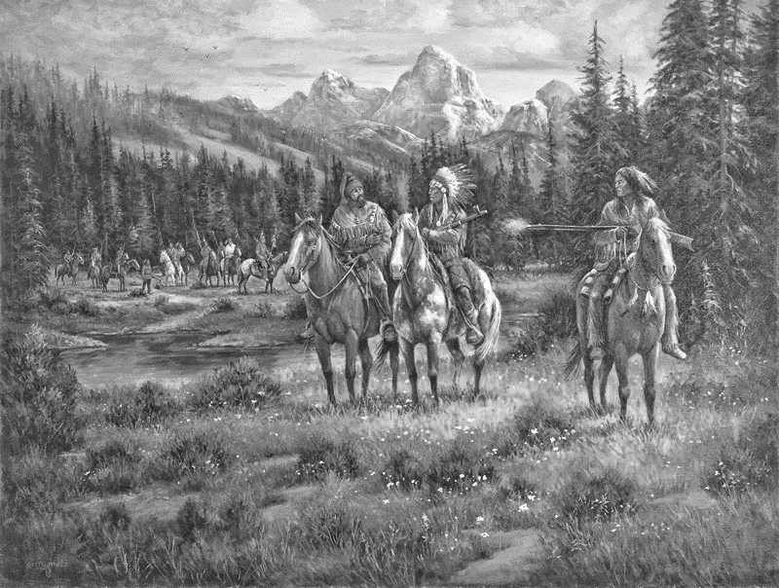
The Sublette Mountain Range east of Malta and the community of Sublett were named after one of the five Sublette brothers, but by now, no one knows which one. William Sublette answered an 1822 newspaper ad placed by William Ashley asking for 100 enterprising men to "ascend the river Missouri". Well known mountain men Jim Bridger, Tom “Broken Hand” Fitzpatrick, and Jedediah Smith were also part of “Ashley’s Hundred”. William gained fame as a trapper, explorer and partner in several prominent fur companies and later as a land speculator. William was badly injured in a fight with Indians during the 1832 Rendezvous at Pierre’s Hole west of the Tetons. A jig saw puzzle entitled, “The Revenge of Antoine Godin”, led us to a discovery of the tragic events at that 1832 Rendezvous. The puzzle shows the Teton Mountains in the background. A group of Indians are putting up their tents. Three men including an Indian Chief are in the foreground. As we put the puzzle together, we realized that there was a puff of smoke coming from a muzzle loader held by one of the men. We began to research Antoine Godin. He was part French and part Indian. His father, also a trapper, had been killed by the Blackfoot. When the Gros Ventre (pronounced Gro Vant) Indians, an ally of the Blackfoot, came into Pierre’s Hole, Godin was for some reason triggered. He and his friends enticed the Chief to meet them away from his tribe. They shot and killed him, stealing his red blanket and then racing on their horses back towards the company of trappers who were camped some distance away. The Indians, upon realizing that their chief was dead, took up their weapons and began chase, firing at the trappers. The trappers returned fire, not understanding why they were being attacked by the Gros Ventre. Many were killed on both sides and William Sublette was severely injured. His injuries prompted him to turn from trapping to owning one of the fur companies. As soon as his four brothers were old enough, they joined William in the West. Milton was a well known trapper, explorer and guide. He lost his leg and walked on a cork peg leg or rode in a cart pulled by a mule the rest of his life. Milton served as a guide for Marcus and Narcissa Whitman. He died at a young age from an infection in his amputated leg. Pickney was killed in an Indian attack shortly after joining his brothers and Andrew was killed by a grizzly bear. Brother Solomon was credited with scouting the Sublette Cutoff in Wyoming
Joseph Rutherford Walker is credited with forging over five hundred miles of the California Trail, including the path through the Raft River. He moved to Missouri from Tennessee when he was twenty and spent most of his life exploring the uncharted territory of the west. He could remember topography and geography of the country he passed through and loved the exploration of new land. He married an Indian woman and she and their family accompanied him on his many adventures. Walker led the first group of Americans to the California coast and back to Utah. He scouted for John C. Fremont and worked with Kit Carson. He guided the Chiles company to California, with Walker Pass being named in his honor. He rounded up horses and trailed them to markets all over the west. Walker was one of the great American explorers.
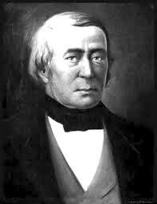
Tom “Broken Hand” Fitzpatrick left his home in Ireland as a teenager, somehow ending up in Missouri where he joined Ashley’s Hundred. He was one of the most influential of the mountain men and figured prominently in the history of the California Trail. In 1832, the year of the unfortunate Godin incident, Tom and William Sublette left St. Louis with supplies for the Rendezvous at Pierre’s Hole. Tom rode ahead to inform the trappers that supplies were on their way. When Sublette’s party reached Pierre’s Hole, they discovered that Tom had not arrived. A rescue party set out and they finally discovered him. Tom had encountered a marauding Indian party and spent several harrowing days eluding them. He was starving and in bad shape. The ordeal was so trying that his hair had turned white. A few years later, a musket misfired, and blew off two of his fingers. After that, the Plains Indians referred to him as “Broken Hand--Chief of all the Mountain Men”. As the fur trade dwindled, “Broken Hand” Fitzpatrick became a well known guide.

Benjamin Bonneville immigrated with his parents from France with the assistance of Thomas Paine, the writer of “Common Sense”. He graduated from West Point and was commissioned in the United States Army. In 1831, Bonneville requested permission for an extended leave from the Army so that he could lead a fur expedition. Some believe Bonneville was an agent for the United States government. Many Washington politicians eagerly eyed the prospect of extending the boundaries of the United States to include Mexican held California and Texas and the British controlled Oregon Territory. Bonneville intended to explore both Oregon and California during his expedition and may actually have been under orders to do so. Bonneville recruited Joseph Rutherford Walker in Missouri as his field commander. He assigned Walker and his men to trap along the Salmon River, but Walker didn’t feel that area was profitable. Walker moved to the Madison River in Montana and then took his men to trap along the Bear River, Bear Lake Valley and Star Valley in Wyoming. His party took in many more pelts than did Bonneville’s group.
Zenas Leonard was a young mountain man who signed on as clerk with Walker’s expedition to California. He was already an experienced trapper. Zenas was gone so long from his home and family without any means of correspondence that they believed him to be dead. His family and friends were elated when he returned home to Pennsylvania five years later, filled with stories of great adventures. He tired of repeating his stories to his friends and neighbors and so published his narratives in the local newspaper. They were compiled into a book and published in 1839.

Joseph Walker and the Trip to California
The 1833 Rendezvous was held at Horse Creek, near Evanston, Wyoming. Walker began to recruit men to fill Bonneville’s assignment to explore the Great Basin and then go on to California. Fifty eight men joined his expedition with orders to meet Bonneville on the Bear River near the Great Salt Lake the following year. Zenas Leonard signed on with Walker, eager for the chance to see California and hoping to finally see some profit. Zenas served as clerk of the company and his records provided him with documentation for his book.
.
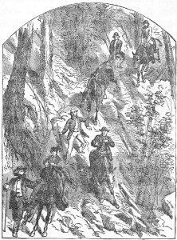
Walker and his men traveled north around the Great Salt
Lake and eventually hit what he called the Barren River
(Humboldt). Roy D. Tea, a well known authority on the Oregon/California Trails, indicates that Walker and his party stayed at Ten Mile Spring on the southeast slopes of the Clear Creek Mountains during their trek west.⁴⁸ They struggled across the Sierra Nevada Mountains. The weary men finally reached the Spanish capital of Monterey and were given permission to winter in California. The next February, Walker’s company headed back towards the Great Salt Lake. The group included “fifty two men, three hundred and fifteen horses, fifty head of cattle and thirty dogs.”
Not eager to retrace their torturous route over the Sierra Nevada, Walker’s party went south where they were guided by local Indians over an easier pass near the southern end of the mountain range. They traveled east and soon came onto the Nevada desert. They found no water and no food for animals or people. They lost sixty four horses, ten head of cattle and fifteen dogs before turning back. They traveled up the Owens valley on the east side of the Sierra Nevada and finally hit the Barren (Humboldt) River. They retraced the trail they had blazed coming west. Near the head of the Humboldt, Walker decided not to continue across the salt flats to the Great Salt Lake but to veer northward where there would be better feed for the animals and hunting for the explorers. Zenas recorded:
We continued our course up Barren (Humboldt) river, without meeting with anything to interrupt us, until about the 20th of June, when we found that if we continued in this direction our provisions would become scarce long before we would reach the Rocky mountains; and accordingly on the 21st our Captain decided on leaving this river and taking a Northern direction for the purpose of striking the head waters of the Columbia river, where we would find game plenty, and also beaver.

The company came to what they called the “Lewis River”, which may have been the head of the Goose Creek.

After laying in a small stock of fresh meat here, we resumed our journey towards the buffaloe country. On the morning of the 3rd of July we were delighted by seeing some buffalo….We travelled a short distance to-day when on arriving at a large spring of most delicious water situated in a beautiful grove where we concluded to spend the National Anniversary of American Independence…

(July 5th) Today continued on search of Capt. Bonneville, on Bear river, in finding whom we succeeded without having much difficulty, on the 12th, after traveling through a luxuriant, though rather rough country.

Most writers claim that Walker and his men came down the Goose Creek onto the Snake River to Fort Hall. One author wrote in an article for the Idaho Historical Society:

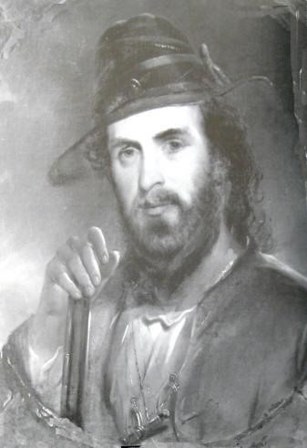
Joseph R. Walker, returning from a fur trade to California, came down Goose Creek, part of which he may have explored above Oakley. If, as is less likely, he came through Granite Pass and approached Raft River via City of Rocks, he was not examining any new country.

We believe that Walker and his company did indeed cross Granite Pass and followed what would become the Salt Lake Cutoff through the Raft River Valley. As the author noted, the Raft River Valley and Snowville Flat were “not new country” to Walker. In fact, if Roy D. Tea is correct in his assumption that Walker and his men camped at Ten Mile Creek on their way to California, they would have traveled most of the route just a year earlier. The only reason that Walker might have taken the Goose Creek route was if he were heading for the Rendezvous held that year near Green River, Wyoming. Walker and Bonneville did not attend the Rendezvous. Bonneville had sent Michael Cerre to St. Louis to pick up his supplies and Cere met Bonneville along the Bear River on July 20. Walker knew the area and would have taken the most direct route to his destination, which would have brought him through the Raft River Valley and the route that would become known as the Salt Lake Alternate to the California Trail.

Zenas Leonard recorded that they were headed for “buffaloe country”. It was well known by that time that the Raft River Valley and the Snowville Flat were home to large buffalo herds. They may have even hunted buffalo there on their way to California. The Rocky Mountains where they were to have met Bonneville likely referred to the rocky crags of the Wasatch Front. The company reached the Bear River only twelve days after they left the Humboldt River. They had stopped to hunt and rest their animals. They could not have made the trip down the Goose Creek, followed the Snake River to Fort Hall, and then traveled down the length of the Bear River in that amount of time.

Changing Times

Glowing reports of Oregon and California were filtering back to the east. Missionaries eager to preach to the Indians joined the fur caravans. Marcus Whitman longed to serve such a mission but his superiors would not allow him to go as a single man. Shortly he was introduced to a young woman with a similar dream. Marcus and Narcissa Prentiss became engaged with the intention of together serving a mission to the Indians. Marcus and another missionary traveled to the 1835 Green River Rendezvous on a fact finding journey for their church. Marcus gained the favor of the trappers by stemming a cholera epidemic and removing an arrow which had been lodged in Jim Bridger’s shoulder for three years. Marcus returned east, married Narcissa and convinced Henry and Eliza Spaulding to accompany them west. They joined a supply train led by one legged Milton Sublette and “Broken Hand” Tom Fitzpatrick to the 1836 Green River Rendezvous. Two trappers from the Hudson Bay Company guided them the rest of the way to Oregon Territory. They followed the trail along the Snake River that Robert Stuart and his company of Astorians traveled in 1812 as they returned east.

The wagons had to be abandoned and Narcissa and Eliza traveled on horseback or in a small cart pulled by a mule. The Spauldings established a mission among the Nez Perce in Idaho and the Whitmans lived among the Cayuse Indians. Their route later became the Oregon Trail and the Whitman mission was the resting place for most of the Oregon settlers.

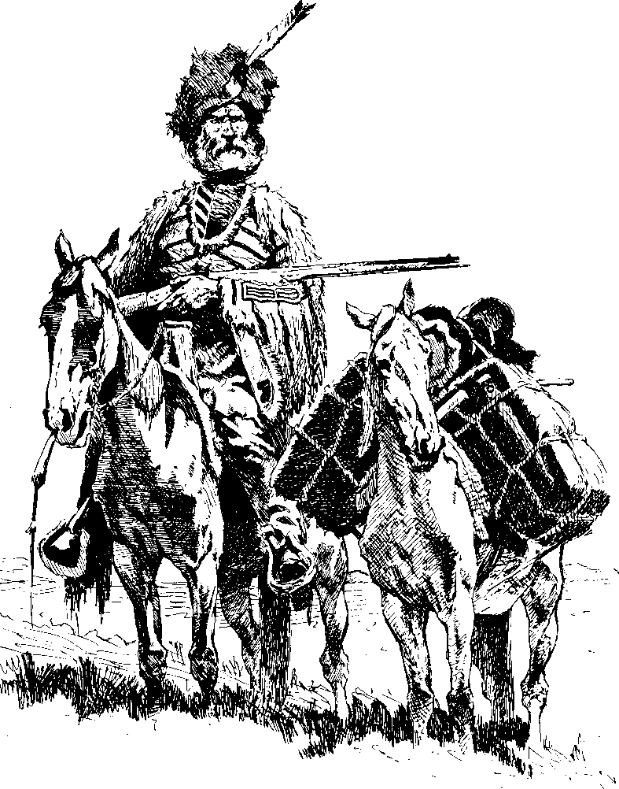
Times began to change for the mountain men. The beaver had been nearly trapped to extinction and men’s hats had changed from beaver to silk. At the last rendezvous which was held in 1840, Doc Newel said to his partner Joe Meeks:
Come we are done with this life in the mountains - done with wading in beaver dams, and freezing or starving alternately – done with Indian trading and Indian fighting. The fur trade is dead in the Rocky Mountains, and it is no place for us now, if it ever was. We are young yet, and have life before us. We can not waste it here; we cannot or will not return to the states. Let us go down to the Welamet [Willamette Valley] and take farms.
While many of the trappers turned to farming or ranching, others saw an opportunity to make a living by guiding the surveyors and the settlers who were now coming west. Many of the mountain men had married Indian women and their families accompanied them on their journeys. Again, several characters emerged during this time whose actions would affect the Raft River Valley. They include John Sutter, John Bidwell, William Chiles, Sam Hensley and John C. Fremont along with the old mountain men, Joe Walker and “Broken Hand” Tom Fitzpatrick. The Applegate family and members of the Mormon Battalion are also part of our story.
Chief Pocatello and his People

The times were also changing for the Northwestern Shoshoni and Bannocks. Beginning in the early 1820’s, interactions increased between the Northwestern Shoshoni and the white men with the incursion of trappers and mountain men. The mountain men would engage Indians as their guides and fellow trappers and many married Indian women. The trapping groups that moved through the snowy mountains during trapping season were composed of women and children in addition to the company trappers and the “free trappers” working for themselves. The horse became more common among the southern Idaho tribes, changing the dynamics of their life.

While the early family groups were governed by older family members, dominant chiefs and leaders began to emerge in the 1840-s and 1850’s. Pocatello, Washakie, Sagwich, Bear Hunter, and Little Soldier were the main leaders of the Shoshoni living from Grouse Creek and Raft River into the Ogden, Cache Valley and Pocatello areas. Each group had their own territory but they frequently interacted with each other, even meeting together in large gatherings.
.
Chief Pocatello whose Indian name was Tonaioza, and his followers ranged from Grouse Creek in Utah, throughout the Raft River Valley into northern Utah, and on to Massacre Rocks and the area surrounding the city of Pocatello. Historian Brigham Madsen who authored several books about the Shoshoni Indians wrote:

That Pocatello’s homeland, stretching from the Raft River along the arc of the northern shores of Great Salt Lake to Bannock Creek and the Portneuf River, lay outside of Mormon settlement seemed to place him and his tribe apart from the other Northwestern Shoshoni. Even modern Indian descendants of these bands consider him and his people to have been separate and distinct because of his independence.

Pocatello’s “independent” nature would become a hallmark in his interactions with the settlers passing through his territory.

It is generally accepted that Pocatello/Tonaioza was born in Grouse Creek about 1815. Brigham Madsen recorded that in 1940, Mrs. Jeanette Lewis, a granddaughter of Pocatello’s mother was interviewed. Jeanette told how her grandmother, Widzhebu, had been captured on the Raft River by a raiding party of seven Assiniboin warriors. She had a two year old daughter and was expecting a baby. Her daughter was savagely killed by one of the warriors and Widzhebu was taken as a slave/wife to eastern Montana. She made a dramatic escape and covered over 600 miles to return to the Raft River. She was eventually reunited with her parents and husband and her baby daughter was born shortly after. Some writers believed that Pocatello was that baby, but he wasn’t born until a few years later.

Madsen wrote that another of Chief Pocatello’s family, LaSalle Pocatello, told an interviewer in 1980 that his ancestor was a “Flathead named Cornell” and that if the tribal leaders knew their parentage, the family would not have been recorded on the Northwestern Shoshoni tribal records. Madsen then goes on to conclude that Pocatello’s father was likely a Shoshoni from Grouse Creek.

Charles Albertson came as a child to Albion, Idaho, in 1877. Their homestead was along Marsh Creek. Chief Pocatello and many of his tribe would come from the Fort Hall Reservation in the summer and camp in their traditional spot in the meadows of the Albertson homestead. Charles spent much time playing with Chief Pocatello’s grandchildren. Charles wrote in his autobiography that Pocatello’s father was not a Bannock Indian but belonged to an Eastern tribe. He had married a Bannock woman, eventually becoming chief.
Pocatello’s father, whatever his heritage, had likely never been a chief because the tribes had been under family leadership up until the 1840’s. Pocatello rose to leadership beginning about 1847. Brigham Madsen who greatly admired Pocatello wrote:

Tonaioza, soon to be known as Pocatello, in about 1847, became the head man of Kuiya, a village of fifteen Tubaduka families located near present Lynn and Yost in Raft River valley. Although young at the time, he demonstrated the personality, ambition and independence of mind necessary to become the spokesman and leader of his people. Within five or six more years, he had extended his influence over another village, Biagamugep, (near the later railroad freight station at Kelton, north of great Salt Lake), where the Kamuduka accepted him as chief. By the time of his first appearance in written history in 1857, he was also in control of other Kamuduka at Bannock Creek and at the bend of the Portneuf River and north to the present city of Pocatello. Perhaps as many as four hundred people acknowledged him as the head of these combined Northwestern Shoshoni groups.

The First California Pioneers
John Sutter left his home and family in Switzerland after a series of bad business deals left him destitute and sought by creditors. He immigrated to Missouri and was unsuccessful as a trader along the Santa Fe trail. In 1838, Sutter joined a fur caravan bound for Fort Vancouver by ship around the tip of South America. His dream was to go to California, but the only ship available was headed for Hawaii and then Fort Vancouver. Sutter booked passage and sailed anyway. In Hawaii he lined up several financial backers and convinced a handful of Hawaiians to accompany him to California. The only ship leaving Fort Vancouver was headed for Sitka, Alaska, which at that time was claimed by Russia. Sutter and his Hawaiian friends figured they could get passage from Sitka to California and boarded the ship. They finally reached California and Sutter received a land grant and permission to establish a colony from the Mexican government. Sutter loaded his men and supplies onto a small boat and explored the Sacramento River. At the junction of the Sacramento and the American Rivers, Sutter laid claim to a vast amount of land and began to build his empire. Nearly every American coming to California would be welcomed by Sutter’s hospitality and were often employed in his businesses. Unfortunately, he died penniless in the east where he had gone to seek redress from damages inflicted on his properties by the gold seekers of 1849.
Antoine Robidoux was an early mountain man who had been to California and finally returned to the east. He organized meetings to speak to his neighbors about the wonders of the land. Listeners became so excited that five hundred people signed a compact to meet the next May ready to travel to California. When spring came, less than sixty settlers showed up including nineteen year old John Bidwell who would become governor of California and Joseph Chiles who would lead seven wagon trains to California. The settlers were determined to go to California and fortunately found a group of Catholic priests under the leadership of Father DeSmet who were headed to Oregon. The priests had engaged “Broken Hand” Tom Fitzpatrick as their guide. They reluctantly agreed to allow the wagons to join their pack train, even though they feared that the fifteen wagons and the women and children would slow their progress. John Bartleson insisted that he be made captain of the California company or he and his men would withdraw. His leadership proved to be disastrous, but the settlers felt they needed the extra support for safety and agreed.
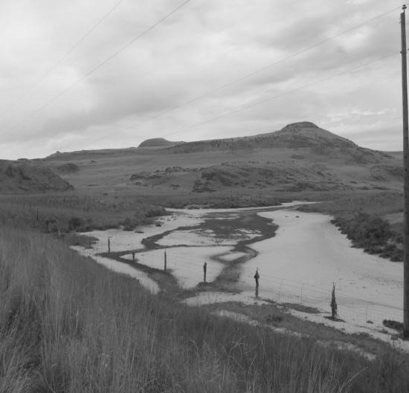
“Broken Hand” Fitzpatrick had not been to California and could only give the Bartleson/Bidwell company general directions. On one of his trapping expeditions, he had sent a group of men including Jim Bridger to float the Bear River. They eventually made it to the Great Salt Lake and back to rejoin Fitzpatrick’s company. “Broken Hand” knew the general direction of the Bear River’s flow but was unaware of its meanderings. He felt the travelers best chance was to follow the Bear River to the Great Salt Lake and then go west around the north end of the lake. They parted company at Soda Springs, Idaho. Tom suggested that they send a group of men on to Fort Hall to see if someone could give them more detailed information about the route to California. To their consternation, there was no one at the fort who could help them. About half of the group decided it was safer to go to Oregon with Fitzpatrick’s party. The group had to abandon their wagons along the way, but reached Oregon territory safely. Thirty two settlers including a young wife and her toddler daughter were determined to go to California. John Bidwell later wrote, “Our ignorance of the route was complete. We knew that California lay west, and that was the extent of our knowledge.”⁵⁸
Without a guide, the Bartleson/Bidwell party struggled. They followed the long and winding Bear River in and out of Cache Valley and northwest of present day Brigham City. The water in the river became so salty that the pioneers could not drink it. Late one afternoon, the travelers thought they saw a line of trees in the distance. Desperate for water, the company struggled ahead until nearly midnight. Their wagons became bogged down in the white sand. As the settlers struggled to free the wagons, they realized that they were digging in sand, not salt. Th trees had been a mirage and they were on the banks of the salty lake.
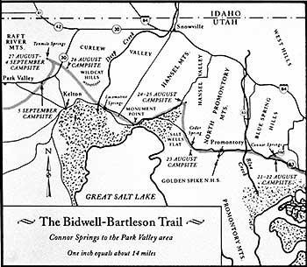
The settlers knew of no other water than the Bear River and traveled the rest of the night back to where the river was not so brackish. After a short rest, they traveled northwest, hoping to be able to bypass the lake. They crossed their earlier trail. The party watered at Connor Springs, barely able to tolerate the salty water, then headed northwest in a thirty mile ordeal across the barren waste towards the Clear Creek Mountains . They missed every spring along the way, but finally came upon an Indian trail which they followed to Ten Mile Spring. Ogden and his men had camped there years before. The company rested at Ten Mile Spring for several days while a group was sent to scout the route ahead. Bartleson and his men left the company only to beg to rejoin a few days later after they had been sickened by some fish they had bartered from local Indians.

Their luck did not improve. They traveled along the south side of the Clear Creek Mountains, through Park Valley, Lucin and on to the Ruby Valley. It was some time before they discovered the brackish Mary’s River (Humboldt). They abandoned their wagons in Nevada and nearly lost their lives crossing the treacherous Sierra Nevada mountains. The desperate travelers were welcomed by Sutter where Bidwell and others were employed. Joseph Chiles was not discouraged by the hard journey. The next spring he returned east, hoping to bring his family and friends to California.
There is no record of his travels on his return east, but it is widely held that in 1842, Chiles came over Granite Pass, through the Raft River Valley and on to the Oregon Trail at Fort Hall.

Applegate Trail
Several wagon companies came west in 1843. The Whitmans received word that their mission was to be closed. Marcus and a friend made a daring mid winter trip from the mission in Walla Walla down to the Santa Fe Trail and eventually back east where he persuaded the Church to continue funding the mission. He also met with members of Congress trying to encourage support for the settlement of Oregon Territory. At Independence, Missouri, Marcus had met a group of nearly 1000 settlers including the extended Applegate Family who were headed to Oregon. He promised that he would catch up with them and serve as their guide to Oregon.
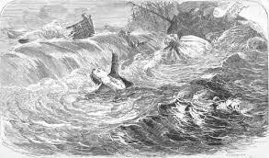
Marcus met them at Fort Hall and under his direction, the company took the first wagons through to Oregon. The passage from the Whitman mission to the coast was nearly impassable through the Columbia River Gorge. The settlers built rafts to float their families and possessions down the Columbia River while the livestock were herded overland over rough volcanic terrain. It was the only way to reach the fertile land in the Willamette Valley. The rafts of the Applegate family were caught in the treacherous rapids near The Dalles. Two young children and an elderly uncle drowned when their rafts overturned. The Applegate brothers hoped to save other families the heartache they had experienced and scouted a route from Southern Oregon which connected with the California Trail in Nevada. They determined the route that came through the Raft River Valley to be the best route to Southern Oregon. One of the brothers was sent to Fort Hall to apprise other pioneers of the new Applegate trail which they felt was safer than rafting the Columbia even though the route had challenges of its own.

The California Trail

That same year, Joseph Chiles of the Bartleson/Bidwell party headed back to California guiding a company of thirty mounted men, six women and three wagons. Sam Hensley and John Jacob Myers, future players in the settlement of the west, were in the company. One source indicates that “Broken Hand” Fitzpatrick guided the group part of the way, apparently planning to break off at Fort Hall and head for Oregon. The group had been unsuccessful in restocking at Fort Laramie. The British continued their policy of trying to keep Americans from gaining a foothold in the Oregon Territory and instructed the traders at the forts not to supply the settlers. The Chiles company met Joe Walker and his Indian wife outside of Fort Laramie. Low on supplies, Chiles was fearful that he could not get the company to California before the winter snows and enlisted Walker’s help. Walker discovered that his nephew and other friends from Missouri were in the Chiles’ company. About half of the group were women and children and only Chiles and Fitzpatrick had any wilderness experience. Walker agreed to guide the party to California. By this time he had been to California several times and had established a successful business buying and selling large herds of horses throughout the west. Walker and Chiles hoped to buy supplies at Fort Bridger. The British traders were not only reluctant to sell the Americans supplies, but an Indian attack had burned most of their provisions and run off the game.
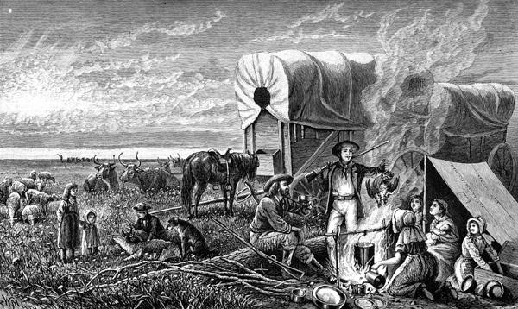
The settlers trudged on to Fort Hall where Walker and Fitzpatrick were welcomed warmly, but again were refused anything but the barest supplies. Walker sent Chiles and about ten men including Sam Hensley and John Myers with Fitzpatrick to Fort Boise in hopes of buying provisions. They were to meet on the Sinks of the Humboldt.

Most sources indicate that Chiles had returned to the east through the Raft River Valley and that Chiles told Walker how to take the wagon company across that route. They also suggest that Chiles decided to go to Fort Boise after giving Walker directions to the Raft River. That Chiles would give such advice to the vastly more experienced Walker seems highly unlikely. This again raises the speculation that Walker had come through the Raft River Valley on his way back from his first trip to California. It would have been unwise for a guide to take a company of family members and friends across an unknown trail when even a day or two of delay could prove disastrous in crossing the Sierra Nevada.

Walker led his party through the Raft River Valley and on, leaving a path through the unbroken sod that would soon become part of the California Trail. They waited briefly at the Humboldt Sinks for Chiles but dared not risk any more delay. Walker followed along the Humboldt, turned down the Owens Valley and crossed at the southern end of the Sierra Nevada where he and his men had come ten years earlier. Lack of supplies and the need to hurry forced them to abandon their wagons in the Owens Valley. Walker left the group at a ranch that belonged to an American acquaintance and headed south where he would meet John. C. Fremont, the famous Army surveyor. Most of the pioneers started north. Many reached Sutter’s Fort where they were made welcome.
Chiles and his men reached Fort Boise where they were again refused supplies but given a roughly drawn map showing a path through Oregon and around the Sierra Nevada mountains. Walker may have told them about the area as well since he had run horses on the Rogue River. They finally made it to Sutter’s Fort, rejoining their friends and family.

Stephens-Murphy-Townsend Company
The next year (1843), a large company of wagons gathered at Council Bluffs. Most were headed for Oregon, but a group of about fifty people were bound for California. The California company, known as the Stephens-Murphy-Townsend party, were guided by two mountain men who unfortunately had not traveled to California either.
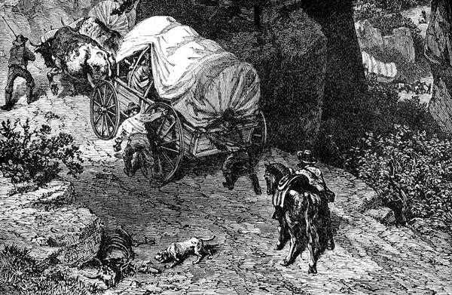
The two groups of travelers separated at the Parting of the Ways near the junction of the Raft and Snake Rivers. They could see evidence of the tracks of the Walker/Chiles party that had come the year before. They did not know if Walker’s company had gotten through, but they decided to take a chance and follow their trail. This established the Raft River route as the main trail to California. ⁶⁷
Some say that if the Bidwell party had been more successful finding water, their route south of the Clear Creek Mountains would have been the preferred route since the railroad came that way as well. Again, this leads to the belief that Walker had knowledge of the Raft River valley and the adjoining area and was familiar with the watering spots.
When the Stephens-Murphy-Townsend party reached the Owens Valley they encountered an Indian they assumed was named Truckee. Through sign language and drawings in the dirt, Truckee showed them a pathway through the Sierra Nevada which would save them miles of travel over Walker’s route the year before. It was a treacherous path and they had to abandon most of their wagons. They were able to get the remaining wagons down the steep mountainside only by leading their animals through a narrow gap in the rock, then taking their wagons apart and lowering them by rope. As impractical as that was, they are still credited with bringing the first wagons to California. ⁶⁸
John C. Fremont
After leaving the Chiles wagon train in California, Joe Walker and eight men headed for Pueblo de Los Angeles to purchase horses to sell at Fort Bridger. They encountered John C. Fremont in southern Utah and though Fremont had already hired Kit Carson and “Broken Hand” Fitzpatrick, he paid Walker to save them from the threatening Indians and guide them to Utah Lake.⁶⁹ The Indians turned out to be under Chief Walkara, a great friend of Walker.⁷⁰
--------------------
- Lee Schegg. “Opening of the California Trail.” Westerly Journeys. Westerlyjourneys.com/goldrush/goldsteph-murphy.html. Accessed: 30 January 2013.
- “The Stevens-Townsend-Murphy Party.” The Truckee Donnor Historical Society Inc. www.truckeehistory.org/historyArticles/history23.htm.
- “California Expedition 1833-1834.” Silver Spur Publishing. www.silverspurbooks.com/california.htm.
- The Fur Trapper. “Joseph Walker”.
- Picture: Hezekiah Butterworth. Young Folk History of America. Ushistoryimages. Accessed 3 March 201
A highway information sign at the Parting of the Ways on the Raft River states that John C. Fremont camped on the Raft River on September 26, 1843, the same year that Walker led the Chiles Party. We haven’t been able to find any more information on this.

John C. Fremont was a rather controversial figure. The son-in-law of a prominent Missouri senator, he shared the senator’s vision of Manifest Destiny. As an officer in the United States Army, Fremont was sent west on several surveying trips, mapping the Oregon Trail as well as surveying much of Utah. Most historians believe that Fremont and others including Captain Bonneville were sent west to spy out opportunities to take over both Oregon and California for the United States.
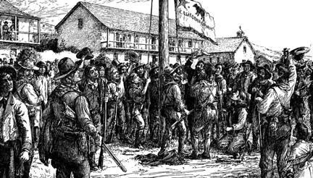
On his third surveying and mapping expedition, Fremont and his men inexplicably turned up in California. By this time, Mexico had won its freedom from Spain and controlled Texas, California, Arizona, New Mexico, Colorado, Nevada and Utah. The area just south of the Almo Valley was part of Mexican territory. Political opportunists and pressure from American settlers in California pushed the United States government to take possession of the Mexican lands. The United States declared war against Mexico in the spring of 1846. An American flagship operated off the coast of California and troops invaded Mexico, capturing Mexico City. A group of American mountain men and settlers declared freedom from Mexico, raising their Bear Flag over government buildings in Sonoma, California.

Fremont’s sixty well armed soldiers were waiting for such an event and some believe that Fremont fueled the revolt. With the declaration of war a few weeks later, the American settler who had been acting as governor turned control over to Major Fremont who replaced the Bear Flag with the Stars and Stripes. Sam Hensley and John Myers, both of whom had come to California with Chiles served as a Captains in the California Battalion under Fremont during the revolt. Commodore Stockton, commander of the American flagship, was the ranking officer in California. He appointed Major Fremont as Governor of California.

The Mormon Battalion
At this same time, members of the Church of Jesus Christ of Latter-day Saints were strung across Missouri and Iowa, seeking a place to gather and prepare for a trip westward. Their prophet and his brother had been martyred. The mobbings and persecutions had increased and the leaders had agreed to leave their settlements in and around Nauvoo, Illinois. The first group crossed the Mississippi River in the dead of winter. Other groups left Nauvoo as soon as soon as they could provision themselves. Their request to winter on Indian lands had been denied and there was nowhere to go. An emissary sent to President Polk reached an agreement that the Church would provide a battalion of 500 men to join General Kearny’s army which was being sent to California to fight the Mexican War. In return the Mormons were allowed to establish a temporary settlement at Council Bluffs, Iowa, and receive payment for the men’s service. It was a great blessing to the Latter-day Saints.
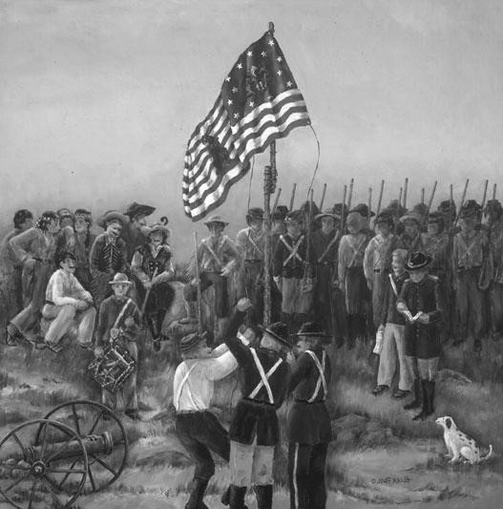
The Mexican War is largely overlooked in American history but it significantly changed the course of the American West. Under Mexican rule, all foreign settlers were required to become Mexican citizens. The Mexican republic had “disestablished” the Catholic missions created by the Spaniards and confiscated their lands and money to fund the government. The Mormons may not have been given permission to settle in the Great Basin. At best, Brigham Young and the Mormon Church would have been under Mexican control, their resources subject to its government. Brigham Young was known as a great colonizer. He established between 350 and 400 settlements throughout the West. Under Mexican control, the great exodus to Utah and subsequent colonization could not have happened.
The five hundred men for the Battalion and the few wives and families who served as cooks and laundresses were mustered from the makeshift settlements and wagon trains which stretched from Nauvoo to Council Bluffs. The Mormon Battalion marched through the southwest following the Santa Fe Trail. It was an arduous journey. At Santa Fe, a battalion of sick soldiers was sent north to an American settlement at Pueblo, Colorado.
When Brigham Young’s Camp of Israel crossed the plains the following year, the Sick Battalion and the Mississippi Saints who had also wintered at Pueblo followed them into the Salt Lake valley.

The main forces of the Mormon Battalion followed General Kearney from Santa Fe to Las Vegas where they established a fort, and then on to San Diego. By the time they reached California, the Mexican War had ended. The treaty set the current boundaries for most of the southwestern United States. The drama, however, had just begun.
Navy Commodore Robert Stockton, the ranking military officer, had appointed Fremont as the military governor. Upon his arrival in California, General Kearney declared himself military governor. He outranked Commodore Stockton and claimed to have been appointed to the position by the government in Washington. A controversy ensued. Fremont refused to step down, not counting on Kearney’s political and military backing. Kearney had Fremont arrested and taken to Washington for court martial.⁷⁵ General Kearney assigned several members of the Mormon Battalion to escort Fremont east. Fremont’s supporters were incensed and a large group of his friends including Commodore Stockton, Sam Hensley, Benoni Hudspeth and John Myers traveled overland to testify in Fremont’s defense. By this time, the California Trail was firmly established and Stockton’s group came through the Raft River Valley and on to Fort Hall. Fremont was ultimately court-martialed but immediately pardoned by President Polk.
When spring came, Sam Hensley and ten former soldiers who had gone to Washington to defend Fremont returned to California. The men were all experienced mountaineers. They stopped briefly in the new settlement of The Great Salt Lake City and then headed across the Bonneville salt flats following the ill fated Hastings Cutoff. They anticipated a quick and uneventful trip. An unexpected and heavy rain storm turned the salty ground to a quagmire. ⁷⁸

Hensley told his story to a fellow traveler with whom he had shared a campsite in Wyoming and then met later along the Goose Creek.
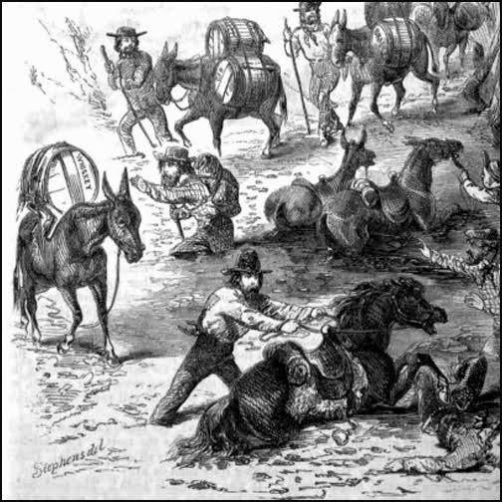
"He [Hensley] intinded to pass to Fort Bridger & Thence South of Salt lake intending to follow [Hastings] Trail. He passed on without difficulty untill he Reached the South western portion of the Lake and Traveled Several Miles upon an incrustation of Salt and unfortunately for the Major and his Train (ten in number) There fell a heavy rain which so weakened the encrustation that they were verry near perishing in the mire. They were under the necessity of Cutting Loose the packs to Save the animals. In this way they lost their provision or nearly So with part of their clothing. They were 48 hours without food or water and hard at work most of the time to Save the Property. They then retraced their Steps to the Mormon City and there replenished their Larder."⁷⁹

As soon as they had “replenished their larder”, Hensley and his men started again for California. After crossing the Bear and the Malad Rivers, they traveled through the Hansel
Mountains and across the Snowville Flat. The Hansel Mountains are thought to be named after Hensley, but with his name misspelled. Unlike the Bartleson and Bidwell company, Hensley and his men found good watering holes including Deep Creek, Blue Creek and Pilot Springs. They camped at Emigrant Springs in the foothills of the Clear Creek Mountains, not far from Ten Mile Springs where Bidwell and Ogden had both stopped. The travelers crossed the Kelton Pass into the Raft River Valley and followed the Raft River west. Bypassing the established California Trail at Fort Hall saved Hensley and his men over a week’s travel time.
Hensley and his men had passed through the Almo valley and the City of Rocks the year before following the California Trail east. Clearly, the men were confident that they could find passage through the country north of the Great Salt Lake and join the California Trail.

Hensley and the Mormon Battalion
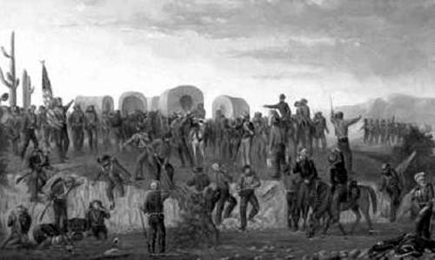
The members of the Mormon Battalion were discharged at San Diego in 1847. Most of them traveled north, reaching Sutter’s Fort where they found temporary work. They received word that the first group of Latter-day Saints had settled in the valley of the Great Salt Lake. The men were eager to join their families and friends. Over two hundred and fifty members of the Battalion started east over the Truckee pass.

At Truckee Lake, they met James Brown, the commander of the Sick Battalion. He was enroute to California to collect the pay owed to his Sick Battalion soldiers. He carried a message from Brigham Young. The fledgling settlement did not have enough supplies to care for any more people through the winter. President Young requested that the soldiers stay in California until the next spring. He hoped they would be able to purchase provisions with their wages and bring supplies with them to Salt Lake City. It was a devastating blow to the men. A large group of Battalion members continued east to join their families who were still in Council Bluffs, Iowa, and bring them to Salt Lake. The rest of the soldiers reluctantly returned to Sutter’s Fort.

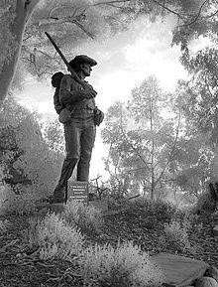
The men hired on with the hospitable Captain Sutter. Six of the men were working at Sutter’s saw mill when gold was discovered. Two of their companions who were working at the nearby Sutter gristmill came to confirm the rumors of the discovery. On their way home, they discovered gold at Mormon Island which would prove to be one of the richest gold deposits. When spring came, the men of the battalion were only interested in returning to their families. As soon as it was possible to cross the Sierra Nevada, the battalion members prepared to travel east. The Thompson/Holmes company left the end of July 1848. The company consisted of forty-five men and one woman. The group had determined to go through Carson Pass which was named after Kit Carson who had guided Fremont over the mountains. Three men decided to go ahead and scout out the pass. When they did not return, the rest of the company became uneasy. A few days later the company camped at a spring. They noticed newly turned dirt and blood covered rocks. They discovered “three of our brethren very badly mangled and bruised to death and put here.” They named the place Tragedy Springs. A few days later, the men encountered a group of Indians who wore pieces of clothing which had belonged to their dead comrades.
The Thompson/Holmes party of the Battalion brought the first wagons from west to east. They made good progress going up the mountain, but coming down a canyon on the other side they came across many large rocks between eight to ten feet high. It seemed impossible to go any further. Zadoc Knapp Judd recorded:
We had no hammers nor drill with which we could do anything with the stone. It seemed almost an impossibility to go further. Finally some one suggested that we build a fire on the rocks, and as there was plenty of dry logs and brush near, there was soon a good fire blazing on each rock that lay in our way. When the fire had died down and cooled off a little, we found that as far as the heat had penetrated, the rocks were all broken in small pieces which were soon removed with pick and shovel and another fire built with the same result.
After building three or four fires, we found that the rocks were not much in our way, and we soon had a good wagon road right over them, and we were a short distance of the old wagon road on Truckee River.
Sunday, August 27th, the men had just completed their prayer services when Sam Hensley and his ten men rode into camp. Learning that the battalion members were going to Salt Lake City, Hensley gave them a “way bill” or description of the route he had just come. He told them that it could save them eight to ten days of travel if they did not go to Fort Hall before cutting back towards Salt Lake. Henry Bigler wrote:
Sun 27th lade by plenty of good grass at 3 oclock the camp cum together at Br. Pratts waggon and had a prair meeting, just as meeting was over we was met by Capt. L. Hensly a packing company of (10) men we got a way bill of our road from here to Salt Lake and not go by Ft. Hall and save about 8 or 10 days travel, we learn from Mr. Hinsly that it is not more than about 380 miles to the lake to take a serten cut off which we are sure to find with plenty of water and grass a rout that he cum but wagons have never went thare before a good wagon rout he got defeated in attempting to go Haistings cut off and turned back and found this knew rout of 70 miles saveing about
Three days later, the company met Joseph Chiles who was bringing another wagon train to California. Hearing of their encounter with Hensley, Chiles gave the company instructions to find the Bidwell/Bartleson trail that he had traveled in 1841. Bigler recorded:
Wednes. 30th We bought of the emegrants some bacon and buffalo meats and got a way bill of Mr. Childs the captain of the company of 48 wagons. The bill or chart claims to give a nearer rout to Salt Lake than the one Hensly gave us.
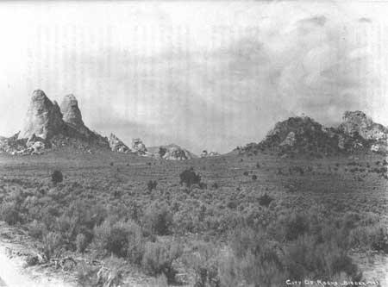
Scouts spent at least two days trying unsuccessfully to locate Chiles’ trail. They finally determined to continue on to the Twin Sisters where Hensley had instructed them to turn off the Trail. Hensley’s company traveled with pack mules, and it was a much more challenging journey with wagons. The battalion men came through Emigrant Canyon and crossed the Almo valley. They forded the Raft River three times in order to get around the shale mountains at the EY Ranch in the narrows. The men camped at Clear Creek. By that time of the year, the creek didn’t flow all the way to the Raft River. One of the men followed the stream up the mountain and caught a mess of trout. The next night’s camp was at Emigrant Springs. The Battalion members were encouraged to realize they were out of the Snake River Drainage and could see the Great Salt Lake in the distance. The lake was more visible from Emigrant Springs before the 1934 earthquake. They crossed the Snowville Flat, forded the Malad and Bear Rivers and followed along the Wasatch Front to Salt Lake. Many of them were overjoyed to find their family members already there.

It is interesting that the Battalion crossed the Raft River three times with their wagons. They discovered an easy crossing just east of Emigrant Canyon. Crossing to the south side of the river missed the convergence of Almo Creek and the Raft River which is swampy ground. They continued down the river and found that the river presses closely against the two hills of the Narrows. They either had to go south around the hills which left them without easy water access or they had to cross the Raft River two more times.
Ebenezer Brown’s Company left California the first part of August and followed the road blazed by the Thompson/Holmes Company three weeks earlier. The company was comprised of 67 people including three women and some Church members who had come to California on the ship Brooklyn. Hensley and his men would have reached California by the time Brown’s company started out, so the Holmes/Thompson group may have left them a way bill or message telling them where to turn off the main trail.

The company reached Granite Pass early in October. They left the California Trail at the Twin Sisters and followed the Holmes/Thompson trail down the Raft River, crossed the Kelton or Strevell Pass and camped at Emigrant Springs. John Borrowman recorded:
Saturday 7 went 8 miles left goose creek went over to ceder branch and went up that to where the road leaves it and went up on the hill and camped and turned the cattle back to the creek to feed
Sunday 8 traveled 20 miles went over the mountains on the devide between ceder branch and providence creek and camped on providence creek good wood and water but p oor grass
Monday 9 went [10] miles down the creek and camped good wood water and grass here we had to fix the road at the crossing of the creek there is at this place two mountains on the South of the creek I call the two sisters
Tuesday 10 we traveled 14 miles and camped by a branch that comes down from the mountains on the south side of the valley this I call flint stone creek
Wednesday 11 we went ten miles and camped at prospect spring and here for the first time our eyes beheld the great Salt Lake our camp was close up to the mountains on the south side of the valley
Descendants of Henry Bigler of the Holmes/Thompson Company settled in Elba, Idaho. The sons and former wife of Benjamin Blanchard Brackenbury of the Ebenezer Brown Company are buried in Almo, Idaho. Many family members still live in the area.
The last and largest group of battalion members to leave California was the Jefferson Hunt/Levi Hancock company. Leaving the end of August, they elected to go over Truckee Pass which the Stephens-Murphy-Townsend party had first crossed four years earlier. They passed the site of the Donner Party’s tragic struggle to survive the brutal winter of 1846-47. At least one of the men had been involved in the rescue of the Donner party and was familiar with the area which may have been why they chose that route. Unaware of Hensley’s cutoff the men followed the California Trail through the Raft River Valley, on to Fort Hall and then back to Salt Lake. It was a hard trip and the men were exhausted and low on supplies by the time they reached Salt Lake City, proving the worth of Hensley’s cutoff. ⁹⁰
Hensley and his men were not the first to cross the Snowville Flats en route from Salt Lake to the Raft River Valley. If they had not encountered the Mormon Battalion and given them directions to the cutoff, Hensley’s “discovery” would have gone unnoticed. The fact that the Mormon Battalion was able to scout a viable wagon route made it possible for tens of thousands of forty-niners to re-provision in the newly settled Great Salt Lake City and rejoin the California Trail at the Twin Sisters. This combination of events made Hensley’s discovery notable.
The discovery of gold drew tens of thousands of treasure seekers to California. While many of the would be miners headed for Great Salt Lake City to resupply and rest their animals, others were in a hurry to reach California. Anything that could shave off a few miles or a little time drew the interest of the 49ers.

Hudspeth’s Cutoff

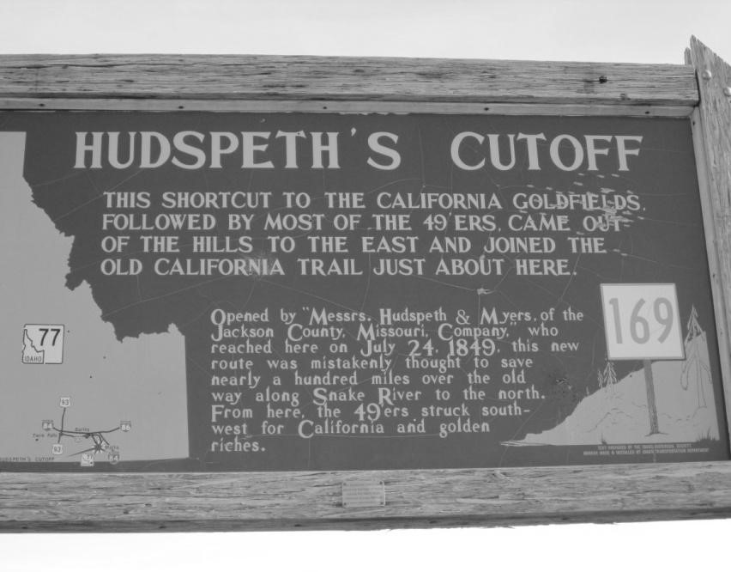
In the spring of 1849, Benoni Hudspeth, his four brothers and John Jacob Myers left Jackson County, Missouri, with a wagon train of about forty wagons and a hundred people headed for California. Myers was a member of the Walker/Chiles company and had gone with Chiles and Hensley to Fort Boise and on to
California. Myers, Hensley and Hudspeth had all been captains in Fremont’s California Battalion and all had apparently gone east to testify at the trial. Now Hudspeth and Myers were headed back to California. Instead of continuing on to Fort Hall, the wagon train left the main trail west of Soda Springs. Hudspeth and Myers apparently thought that they could shave off several days travel, though it seems that neither of them had actually covered the new route. They had recruited more settlers and now had seventy wagons and about two hundred and fifty people in their company.
When they left the main trail west of Soda Springs, they thought they would save considerable miles and arrive at the headwaters of the Humboldt. To their surprise, they were still in the Raft River drainage when they again came upon the trail from Fort HalI. They actually had saved about 25 miles, but had crossed four mountain ranges and a number of lower, but difficult divides.
The settlers watered at Twin Springs, north of Snowville, Utah, and crossed the Sublette range into the Malta valley. Hudspeth’s Cutoff joined the California Trail at Cassia Creek between Malta and Connor Creek.
It is estimated that from June 20 to August 31, 1849, 250 wagons a day (an estimated 16,000 to 25,000 people) traveled this route, even though it was unproven, more difficult, and as it turned out, did not save any time. The Pioneers were desperate to get to California first.
Although the cutoff did not save any time and was not easy, the Fort Hall route “had difficult places…getting over some bluffs and down to water along the Snake River.” The Hudspeth route offered better grazing for the cattle and the settlers could burn wood instead of sagebrush in their campfires. Some probably took the trail because they thought a cutoff should be shorter.
There is some confusion in the records regarding Benoni Hudspeth and James Hudspeth. The two men were contemporaries; both were trappers and guides.. They were not related. Many articles do not distinguish between the two men. James Hudspeth was with Hastings and may have been partially responsible for the Donner Party’s disastrous decision to go down Emigration Canyon.

The Raft River Corridor
In about thirty years, the Raft River Valley had been transformed from the unexplored wilderness home of the Snake Indians to the site of three trails to California and the Applegate Trail to eastern Oregon. Nearly every early traveler to California had come through this narrow corridor. Nearly every event important in California and Oregon Territory touched the Raft River Valley. The early exploration of the area and the establishment of the trails that crossed through the valley are the just the first part of our story.

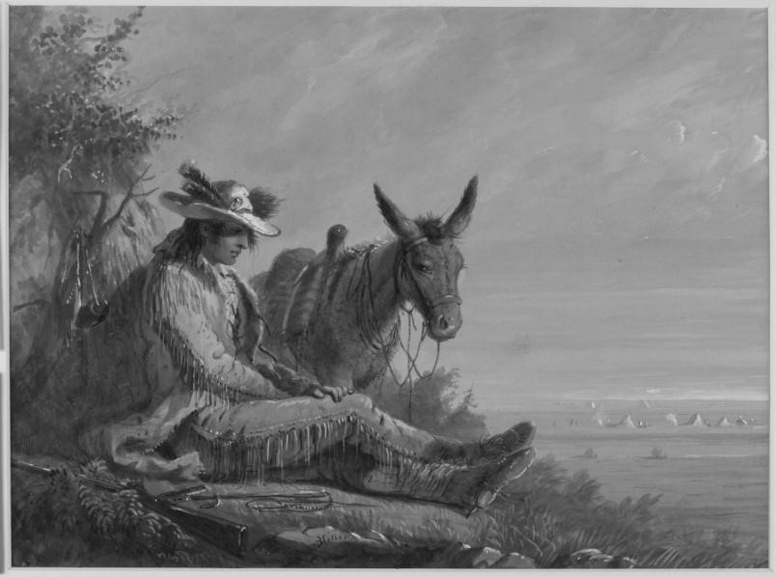

APPENDIX I
Map showing Wilson Price Hunt’s Trail from Missouri to For Atstoria.
From O. Ned Eddins website, thefurtrapper.com. This website has well documented and interesting articles on many of the mountain men and the history of the west.
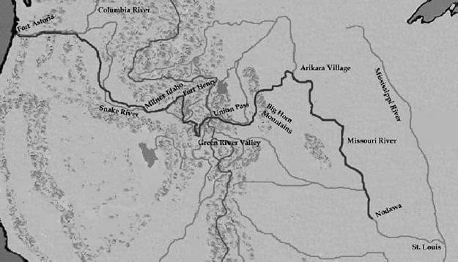

Peter Skene Ogden's Snake Country Journal, 1825-26
The Quarterly of the Oregon Historical Society, Vol. X, No. 4. (December 1909). Editorial Notes by T. C. Elliott.
Copied from: http://user.xmission.com/~drudy/mtman/html/ogdn2526.htmly
Thursday, April 15th. The Piegan chief will leave us tomorrow; he tells us we cannot be too much on our guard; that we are surrounded by war parties.
Saturday, April 15th. Weather mild, wind strong. The Piegans have set fire to the plains to destroy us or collect war parties to surround us.
Saturday, April 22d. Guard informs us three halfbreeds are bent on desertion. I secured their horses, arms and blankets. They do not relish the idea of a journey on foot and followed us; one of them, for his impudence, received a drubbing from me. We camped within two miles of the American Falls.
Saturday, April 29th. Twelve buffalo killed for provisions back.
Saturday, May 6th. Over hilly, stony country, bare of wood to Raft River; began to snow and continued the greater part of the night. Many of the trappers came in, almost froze, naked as the greater part are, and destitute of shoes, it is surprising not a murmur or complaint do I hear; such men are worthy of following Franklin. Two-thirds without a blanket or any shelter, and have been so for the last six months. Thirty-four beaver today.
Tuesday, May 9th. Half the camp ill from meat of beaver fat from eating hemlock.
Sunday, May 21st. The Snakes inform us a party of Americans, about 30 in number, has descended this stream on their return from Salt lake, without beaver; this agrees with the account of Mr. Montain.
Tuesday, May 23d. We saw the corpse of an Indian lying on the plains. The Snakes have a mode of burying their dead different from all other natives; where he falls be is allowed to remain, without a grave or covering; a feast for the wolves and crows; nor is any ceremony observed or grief of long duration; how pleasant to part with friends without regretting them. The Snakes have one advantage over us; I envy them.
Friday, June 2d. Proceeded but a short distance when we met with a Snake; this Indian I saw last year on Bear's River; it was this rascal who headed the party who pillaged us two years ago. He also headed the party who murdered nine Americans and pillaged all their property, and last year again pillaged the Americans of all they had.
Saturday, June 3d. Mr. Dears started from Indian tent in the hope of trade, but without success. In fact, with the Snakes, you must take them by surprise; take their property ere they have time to secure it, and recompense them for it. By any other means, you cannot obtain anything from them, so averse are they to trade provisions, nor do I blame them in such a wretched country; nor would they remain in this quarter, but the dread of losing their scalps. They are surrounded on all sides by enemies; are at peace with Flatheads and Nez Perces, but have the Crows, the Utas, the Saskatchewan tribes to guard against.
Friday, June 8th. Had a visit from the Snakes. Within the last 10 months they have plundered 180 traps from the Americans and guns, knives and other articles. This, with 13 men murdered in 1825, is sufficient to make them independent of trade. The Americans swear to make an example of them; I do hope from my soul they may.
Saturday, June 10th. We started at an early hour; one of the trappers reports that yesterday he saw a party of Indians, 30 in number, who, on seeing him, went off at full speed and took to the mountains. Some are of the opinion they have killed our men left here, or suspect us to be Americans. I feel most anxious about the six men we were to find in this quarter; so far no tidings of them; this gives me hope they are safe; by the route we are taking we cannot be long without hearing from them; I only hope we shall find them alive and well loaded with beaver; we require all to make up our three thousand. Saw a family of Indians on the move; they had no horses and are well loaded - men, women and children with roots; they endeavored to escape from us. They were allowed to pass without molestation. This is the season of roots in this quarter the bitter and another a good substitute for flour, if it were dried. The seed of the sunflower they also collect for food, but it does not appear to be common here. Six beaver from 50 traps today; course, northwest north, 14 miles.
Sunday, June 11. We have every cause to apprehend some treachery from suspicious manner of the Indians. At this season beaver are not easily taken. The bait of castoreum is no inducement as they discharge this castoreum, abandon the female to the young and will live on grass till the sap of the trees ceases flowing and flowers from blooming, when they commence preparing their winter habitation; they are at present very shy. Our last party were to have ascended Sandwich Island River and to have trapped it; and I am surprised not to see them. I rewarded our guide to the amount of eight skins, Indian tariff, and he was highly pleased. Mr. McKay discovered some Snake Indians concealed in the hills, no doubt to steal our horses. This day 44 beaver, which enables us once more to feast. The discontent was dispelled. Gaiety reigns in camp.
Monday, June 12th. Last night we were alarmed by the guide calling out "Thieves." An Indian was seen near the horses, but made his escape; had he delayed two hours longer, when all the camp would have been asleep, he would have succeeded; it will have a good effect on the men. Canadians in general require an alarm every few days to keep on guard. Some of our traps were stolen last night; suspect men ( ?) the camp's. This day we finished our second thousand beaver. If our absent men are safe I trust them to add a thousand more.

Wednesday, June 14th. We trust to chance now as we have no guide and all are equally ignorant of this country. Two Snake Indians, well-mounted, came boldly to camp; they gave us some idea of the road, and no tiding of our absent men. God grant no accident has befallen them.
Thursday, June 15th. All along our route this day the plains were covered with women digging roots; at least 10 bushels were traded by our party; the men (Indians) all gone to join the Fort
Nez Perces Indians. Reached a fork of Owyhee River. Still no account of our men.

APPENDIX II
JOURNAL OF JOHN WORK April 21-July 20, 1831 Snake River Country Expedition
Edited by T. C. Elliott
From Quarterly of the Oregon Historical Society, Volume XIV. 1913.
Copied from: http://user.xmission.com/~drudy/mtman/html/jwork/work09.html “John Work’s Journal.” Mountain Men and the Fur Trade. Sources of the History of the Fur Trade in the Rocky Mountain West. Mtman.com.

Sunday, May 1st, 1831. Heavy, cloudy weather, some showers in the afternoon. Moved camp and proceeded 12 miles S. by W. across a point to the little creek [Rock Creek] where the people have their traps set near the mountains, the road, though a little hilly, was good, considerable patches of snow occupying the north side of the little hills and the bottoms of the deep gullies. This little river is a narrow deep stream resembling the river Bannock, running between steep clayey banks. Where we are encamped is at the entrance of the mountains, the valley is not wide and no wood but some willows on the banks of the river. There is pretty good feeding here for the horses, but farther up the valley, where the snow has but lately disappeared, the men represent the grass as very indifferent, in many places scarcely any. All hands visited their traps, 65 beaver and 1 otter were brought to the camp, but the greater part of them were taken yesterday and left in cache. The traps this morning did not yield according to expectation.
Monday, May 2nd. Cloudy, fine weather, some showers in the afternoon. Did not move camp in order to allow the horses to feed, pretty good grass being at this place, and to allow the men time to take up their traps before we descend again to the Snake river. Some of the people have been up this river as far as there is any wood or beaver. 11 beaver were taken. Some of the men set their traps in the big river.
Tuesday, May 3rd. Cloudy, fine, warm weather forenoon; stormy with thunder and some rain towards evening. Moved camps, and proceeded 10 miles S. W. to the Snake river, where we encamped among hills on the small crawfish river. The road very hilly and fatiguing on the horses, many of whom were much fatigued on making the encampment. They were recompensed by excellent grazing. The men were on ahead setting their traps. 12 beaver and 1 otter were taken.
Wednesday, May 4th. Cloudy, stormy weather. Marched 10 miles W. S. W. to Raft river which we fell upon 10 or 15 miles from its junction with Snake river. The road good but very hilly the forepart of the journey. Raft river is now very high and muddy owing to the melting of the snow. There are some appearance of beaver in it though this part of it was hunted by the Americans last fall. The men visited and changed their traps. 11 beaver were taken. Some tracks of buffalo were seen on the opposite side of Snake river, and the tracks of some herds ascending the river. We have, if possible, to procure a stock of provisions as we have a long way to march through a country nearly destitute of animals of any kind, and this is the last place where we are likely to find any buffalo.
Thursday, May 5th. Cloudy, stormy weather, thunder and some very heavy rain towards morning. Marched 5 miles south up the river, when we encamped, and sent the most of the people after a large herd of buffalo which was discovered feeding in the mountain. Our horses have improved a little and are now able to catch them. The buffalo are beginning to get a little older, and though scarcely the appearance of fat is to be found on the meat, is tolerably palatable. The people visited their traps in the morning, 14 beaver were taken. Gave orders for the people not to go ahead lest they would disturb the buffalo and drive them farther off.
Friday, May 6th. Cloudy, fine weather. Did not move camp in order to allow the people to dry the meat which was killed yesterday. The buffalo are so lean now that they scarcely yield as much dry meat, and of an inferior quality, as one would do in the fall or early part of the winter. 5 beaver were taken.
Saturday, May 7th. Cloudy, fine weather. Marched 12 miles south up the river. The road good, but very indifferent feeding for the horses. A number of the people went after a herd of buffalo which was grazing on the opposite side of the river, and killed several, the meat of which the women are now busy drying. It is fortunate we find buffalo here as it saves us the trouble of going a long day's march to the Eastward, to a place out into the plains called the Fountain where buffalo are always said to be found. It would lose at least three days going to this plain. I had some trouble in preventing some of the men from running ahead of the camp with their traps and raising the animals. Some of them want no provisions themselves and are indifferent whether others have it in their power to get any or not. By missing the opportunity of collecting a little provisions now the people would be obliged to eat several of their horses before reaching the Fort, [Fort Nez Perce] as animals of any kind are uncertain. (?) beaver were taken.
Sunday, May 8th. Cloudy, fine weather. Marched 12 miles south up the river. The road still good, but grass for the horses very indifferent. A number of the people went in pursuit of a large herd of buffalo which was feeding on the opposite shore of the river, and killed a number of them, the meat of which is now being dried. Blackfeet are still following our camp. Two of the young men, who went out into the plain yesterday to discover buffalo, saw them, but were not sure, on account of the haze, whether it was men or antelopes. Two of the men who went back this morning for some traps which they had (left) behind saw the Indians coming to our camp after all the people had left it some time. (?) beaver were taken.
Monday, May 9th. Fine weather. Did not move camp in order to give the people time to kill some more buffalo. Some large herds were found at the foot of the mountains on this side of the river, a number of whom were killed. The most of the people have now nearly enough provisions, what little a few of the people still want we expect to find as we advance up the river. Some marks of Blackfeet were seen near the camp this morning. In the morning the buffalo were observed flying from the mountains to the eastward, and it is conjectured they were disturbed by a band of those marauders.
Tuesday, May 10th. Unpleasant, stormy weather. Raised camp, and proceeded 10 miles south up the river, the Roche, [Must refer to branch of Raft, not Rock river] where it becomes confined in a narrow valley. Here we found good feeding for the horses. No buffalo to be seen today until towards evening when a small band were observed in the mountain. Some of the people went after them, but only one was killed. One of the men, M. Plante, who went after the buffaloes was behind the others when returning and discovered a Blackfoot Indian on horseback and fired upon him but missed. The Indian made off towards the mountain, when five other Blackfeet were observed afoot. These scamps are still following us seeking an opportunity to steal.
Wednesday, May 11th. Cloudy, rather cold weather. Marched 10 miles S. S. W. up the river, the road good. We deviated a little from our straight road today in order to send off a party of our men to hunt in another direction tomorrow. The people visited some traps which were set yesterday and took 6 beaver. No buffalo nor the marks of any to be seen today.
Thursday, May 12th. Fine weather in the morning, but heavy rain and snow and very cold afterwards. Raised camp and marched 10 miles across the mountains, and encamped on a small rivulet of snow water. The head of Raft river appears in a deep valley to the west of us. The road on the mountains hilly and rugged and some places stony, and in places very boggy. The snow still lies in banks of considerable depth, and appears but very recently to have disappeared off most of the ground. The grass is barely beginning to spring up except on small spots exposed to the south, which has been some time clear of snow, where vegetation has made some progress. From the very ruggedness of the road and the badness of tile weather this was a harassing day both on horses and people. For want of water we could not encamp sooner. In order that we may make a better I separated a party this morning and sent 8 men, viz. C. Plante (who is in charge of the party), J. Deslard, F. Champagne, L. Rondeau, L. Quenstall, A. Dumarais, Bt. DubrielIe and A. Longtin to hunt to the Westward on the heads of small rivers which run into Snake river and on the Eastern fork of Sandwich Island River, [Owyhee river] while I with the remainder of the party proceed to the southward to Ogden's river, and then to the head of Sandwich Island river. Plante was directed to push on and make a good encampment today so that he might get out of the reach of the Blackfeet who are still following our track, but instead of doing so some of the people who went in pursuit of a horse that followed the party found the encampment only a few miles from our last night's station. If they push on they will in a short time be out of the reach of the Blackfeet.
Friday, May 13th. Raw, cold weather, froze keen in the night. Marched 15 miles S. E. to the entrance to the plain [Near to Kelton, Utah] of Great Salt Lake. The road very hilly and rugged, numerous gullies to pass, several of which are still full of snow, through which the horses sometimes with difficulty dragged themselves. Nearly all this day's journey through the mountains the snow has but recently disappeared even in patches, and the grass is still so imbedded with water that the horses nearly bog in it. Except a few spots here and there the grass is barely beginning to shoot up, and in many places vegetation is not yet commenced.
Where we are encamped there is a little grass for the horses. This was a fatiguing day on both men and horses, many of the latter with difficulty reached the encampment.
Saturday, May 14th. Cloudy, cold weather. Marched 12 miles S. along the foot of the mountains, and encamped on a small river on Mr. Ogden's usual road to Odgen's river. The road today was good and pretty level though intersected by several gullies, some of which are still full of snow. The mountains to the West are still partially covered with snow, and appear very rugged. To the eastward lies the great plain thickly studded with clumps of hills. About this neighborhood we expected to find some buffalo, and that such of the people as are short of provisions would furnish themselves with some more, but not the mark of a buffalo is to be seen. There are a good many antelopes in the plains and some black-tail chevereau.

APPENDIX III Narrative of the Adventures of Zenas Leonard
A Native of Clearfield County, Pa. Who Spend Five
Years Trapping for Furs, Trading with the Indians, &c., &c., of the Rocky Mountains:
Written by Himself
Of the adventures of a company of 70 men, who left St. Louis in the Spring of 1831, on an expedition to the Rocky Mountains, for the purpose of trapping for Furs, and trading

with the Indians, by one of the company, Mr. ZENAS LEONARD, of Clearfield county
Pa. — comprising a minute description of the incidents of the adventure, and a valuable history of this immense territory — not from maps and charts, but from personal observation. Published 1839.

Excerpt from Narrative covering their departure from the Barren River to their meeting with Captain Bonneville.
We then continued our course up Barren river, with out meeting with any thing to interrupt us, until about the 20th of June, when we found that if we continued in this direction our provisions would become scarce long before we would reach the Rocky mountains; and accordingly on the 21st our Captain decided on leaving this river and taking a Northern direction for the purpose of striking the head waters of the Columbia river, where we would find game plenty, and also beaver.
After leaving Barren river we made a quick passage across the country and the first waters we came to, was Lewis river, near its head, where we found game such as deer elk, bear and beaver plenty. After laying in a small stock of fresh meat here, we resumed our journey towards the buffaloe country. On the morning of the 3d of July we were delighted by seeing some buffaloe in company with four of our Spanish cattle that had strayed a short distance from the main body during the night, two of which our hunters killed, being the first we had seen since we left the Great Salt Lake the year before. We travelled a short distance to-day when on arriving at a large spring of most delicious water situated in a beautiful grove, where we concluded to spend the National Anniversary of American Independence; and accordingly our hunters went out in the afternoon and killed several very fat buffalo, which were dressed and the choice parts prepared for a grand feast on the morrow. When the morn of the glorious fourth first dawned we gave three salutes, spent the morning in various kinds of amusement, and at noon partook of our national dinner, which was relished the better as we had a small portion of good old brandy, which we drank in a few minutes, deeply regretting that we had not a small portion of what was that day destroyed by the millions of freemen in the States. — The remainder of the day was celebrated by drinking toasts, singing songs, shooting at mark, running, jumping, and practising on our horses — having the two Spaniards still with us, who learned us many singular pranks, and were a valuable addition to our company, as they created a great deal of fun, and were always in a good humor.
July 5th. To-day continued on search of Capt. Bonneville,[This name has heretofore been printed Bowville — by mistake.] on Bear river, in finding whom we succeeded without having much difficulty, on the 12th, after travelling through a luxuriant, though rather rough country - where we again had intercourse with people of our own nation, being the first we had met with, except the crew of the Lagoda, since we separated from these same men at the Great Salt Lake. Here we encamped for the purpose of resting a few days, and probably remaining until we would receive supplies of provisions, merchandize, &c., from St. Lewis — spending our time in discussing the many scenes encountered by each of us, and the many hair-breadth 'scapes that such-and-such a one had made.
After remaining in this situation a few days, there arrived at our camp a company the of 25 men belonging to the British NorthWest Fur Company, from Fort Vancouvre, situated near the mouth of the Columbia river. These people informed me that the infant colony at the mouth of the Columbia river had revived, and was now increasing rapidly, under the superintendance of the British, and contained 150 families, the major part of which are English, Canadian, French and Indians, and but few Americans. They carry on agriculture to a considerable extent — the soil being very fertile, climate mild, and frost and snow but seldom known. They also have a Grist and Saw-Mill, and are establishing an extensive fishery at the mouth of the river, for the purpose of catching Salmon, as they are very abundant in this stream. They have a Governor, and live under a Republican form of Government. From all accounts, however, their government is not of much use, as the most unbounded freedom of action is exercised by all the members of the colony, & their government is intended more for effect with the Indians, than any advantage to the people.
About the 17th of July this party left us and continued their journey on search of the Blackfeet Indians for the purpose of trading, — after which they said it was their intention to return to the coast by the same route.
We remained here until the 20th without meeting with any thing particularly, when Capt.
Cerrie joined us with 40 men, bringing a large supply of merchandize packed upon mules and horses from Missouri. With what we had on hand these men brought enough of merchandize and provision to supply our present company for a whole year. This party intended to return immediately to Missouri with what peltries we had on hand.
These succouring companies are always looked for with great anxiety by the people who have been in the mountains any length of time.
APPENDIX IV
BIDWELL/BARTLESON PARTY 1941
From James G. Scrugham, Nevada: The Narrative of the Conquest of a Frontier Land (1935), Vol. I., pp. 62-63. Selection covers John Bidwell’s description of the journey from near Fort Hall through Utah and into Nevada.
(James Scrugham was Governor of Nevada from 1923-1927.)

Copied from: www.nevadaobserver.com/ReadingRoom.htm (Bidwell)
(Quoting John Bidwell) Our party, originally sixty-nine, had become lessened to sixty-four. . . Thirty-two of our party, becoming discouraged, now decided not to venture without path or guide into the unknown and trackless regions toward California, but concluded to go with the missionary party to Fort Hall and thence find their way down the Snake and Columbia Rivers into Oregon. The rest of us—also thirty-two in number, including Benjamin Kelsey, his wife and little daughter—remained firm, refusing to be diverted from our original purpose of going direct to California. . . . We were now thrown entirely upon our own resources. All the country beyond was to us a veritable terra incognita, and we only knew that California lay to the west. Captain Fitzpatrick was not much better informed, but he had heard that parties had penetrated the country to the southwest and west of Great Salt Lake to trap for beaver; and by his advice four of our men went with the parties to Fort Hall to consult with Captain Grant, who was in charge there, and gain information. Meanwhile our depleted party slowly made its way down the west side of Bear River."
"In about ten days," continues Bidwell, "our four men returned from Fort Hall, during which time we had advanced something over one hundred miles toward Salt Lake. They brought the information that we must strike out west of Salt Lake—as it was even then called by the trappers—being careful not to go too far south, lest we should get into a wasteless country without grass. They also said we must be careful not to go too far north, lest we should get into a broken country and steep canyons, and wander about, as trapping parties had been known to do, and become bewildered and perish." It is strange that among the trappers along Bear River or at Fort Hall some member of Ogden's or of Walker's party was not found who could have given more specific directions for crossing the desert north of Great Salt Lake to the Humboldt. The Bartleson party proceeded very slowly, reaching the northern end of Great Salt Lake early in September. From this point Bid well's account best tells the story of the party's experiences.
The principal growth, on plain and hill alike, was the interminable sagebrush, and often it was difficult, for miles at a time, to break a road through it, and sometimes a lightly laden wagon would be overturned. Its monotonous dull color and scraggy appearance gave a most dreary aspect to the landscape. But it was not wholly useless; where large enough it made excellent fuel, and it was the home and shelter of the hare, generally known as the jack rabbit, and the sage-hen. Trees were almost a sure sign of water in that region. But the mirage was most deceptive, magnifying stunted sagebrush on diminutive hillocks into the trees and groves. Thus misled, we travelled all day without water, and at midnight found ourselves in a plain, as level as the floor, incrusted with salt, and as white as snow. . . . This plain became softer and softer until our poor almost famished animals could not pull our wagons. In fact we were going direct to Salt Lake and did not know it. So, in search for water, we turned from a southerly to an easterly course, and went about ten miles, and soon after daylight arrived at Bear River. So near Salt Lake were we that the water in the river was too salty for our animals to use, but we had to use it; it would not quench thirst, but it did save life. The grass looked most luxuriant, and sparkled as if covered with frost. But it was salt; our hungry, jaded animals refused to eat it, and we had to lie by for a whole day to rest them before we could travel. Leaving this camp and bearing northwest we crossed our tracks on the salt plain, having thus described a triangle of several miles in dimensions. One of our most serious troubles was to find water where we could camp at night. . From a westerly course we turned directly north, and guided by antelope trails, came in a few miles to an abundance of grass and good water. The condition of our animals compelled us to rest here nearly a week. Meanwhile two of our men who had been to Fort Hall went ahead to explore. Provisions were becoming scarce, and we saw we must avoid unnecessary delay. The two men were gone five days. Under their lead we set forth, bearing west, then southwest, around Salt Lake, then again west; after two or three fatiguing days—one day and night without water—the first notice we had of approach to any considerable mountain was the sight of crags dimly seen through the smoke, many hundred feet above our heads. Here was plenty of good grass and water. Nearly all now said : "Let us leave our wagons, otherwise the snows will overtake us before we get to California," so we stopped one day and threw away everything we could not carry, made pack saddles, and packed the oxen, mules and horses, and started.
APPENDIX V
Excerpts from Writings of Members of the Mormon Battalion
Copied from the Utah Crossroads Booklet, “Hensley’s Salt Lake Cutoff”
The Utah Crossroads group of the Oregon California Trails Association (OCTA) hosted a tour of the Hensley Salt Lake Cutoff on September 17, 2011. The guidebook for the event includes excerpts from the journals of several battalion members at each step of their journey from Goose Creek to Salt Lake. The journal entries from Granite Pass to Emigrant Springs on the northeast slope of the Clear Creek mountains are included below. The writers include Henry Bigler, Ephriam Green, Jonathan Holmes, Addison Pratt, Samuel Hollister Rogers and Azariah Smith. The Raft River was called “Cassia Creek” by the travelers. Trail excerpts and other information on the Mormon Battalion Companies can be found on the Mormon Overland Trail website under Jonathan Holmes and Ebenezer Brown. (Go to lds.org, click on resources, choose Church History, and Mormon Overland Trail.)

Thursday, 14 September 1848. Near Granite Pass
Bigler—“While at breakfast this morning an Indian came in with a mule to swap for a horse. No doubt but that the mule was a stolen one from some emigrant. Mr. Brown gave the Indian a trade. Made twelve miles and camped in the mountain. At dusk our pilots that had gone In the morning and reported they had found Captain Hensley’s cutoff about eight miles ahead.”
Green—“today I went ahed in company with sidney willes and captain Thompson we had a verry hard days ride we roa[d] about _fty milds to the casier [Cassia] we went back to the camp rather late we traveld 14 milds today and campt at a beautiful spring and very good grass”
Holmes—Made another move traveled 15 miles & campt
Pratt--”About noon we left the creek and ascended some of the worst hills between the Sierra Nevada and Salt Lake, and camped in the mountains near some cold springs.”
Rogers—“We traveled 8 miles down the stream when we left it and traveled 7 miles over a verry rough road. Camped after sun set.”
Smith--“This morning the Pilots went ahead to find the cut off; and we travailed seven miles down the Creek, and then left it and travailed three miles, when we came to a Spring, where we were to stop, til the Pilots came; and we stoped there two or three hours, when Brother Thompson came, and said that there was a place about four miles ahead that would do the camp. So we hitched up and started, but having some very bad hills to come up, we did not get encamped till just dark. Brother Sly came after a little having found the turn off place.”
Friday, 15 September 1848. Cassia Creek (Upper Raft River)
Bigler—“Set off this morning in good spirits. Everyone seemed to feel fine and after making about eight miles we came to a chain of low mountains, and nearby on our left were two towering rocks near each other which Mr. A. Pratt named the Twin sisters. Since known by travelers as the City of Rocks, as there are several masses piled up all around the same neighborhood. Here we left the fort Hall Road on our left taking a course directly east through sage brush and over rocks and boulders and camped on Cash Creek making today about thirteen miles.”
Green—“we started very erly to day we traveled ten milds on the old road we then struck off of the old road and traveld fore milds and struck the cosery [Cassia] we traveld about 16 milds to day to night I am on gard again”
Holmes –“Started this morning traveled 8 miles on the old road & then turned for Hensleys Cut off traveled 8 miles on it & come of Casey Crick”
Pratt—“We left Fort Hall, at the Rock Gemini, and made a wagon road from here to Salt Lake. That night we camped on the headwater of Cassier [Cassia] Creek. This also discharges its waters into some of the larger tributaries of the Columbia.”
Rogers—“Today we travailed seven miles, then left the old road, and travailed two miles furher and camped on the Cajvese (Casver,) a French name.”

Saturday, 16 September 1848. Cassia Creek/Raft River
Bigler—“Continued down this stream ten miles and camped. We were met by eleven Indians of the Snake nation on horseback.”
Green—“the 16 we traveld to day 10 milds crost the river three tims hear we leav the river”
Holmes--“Moved again traveled 12 miles down Casey to the turning off place & Campt. Road good land good Grass & water plenty.”
Pratt—“we traveled down and camped again on the Casier. Here the stream was large and afforded plenty of trout.”
Rogers—“We traveled 10 miles crost a stream on the way camped on its bank.”
Smith—“Today we travailed ten miles in an easterly direction, and encamped again on the
Cajvese, in a notch in the mountains. We saw several Indians on horseback.”

Sunday, 17 September 1848. Clear Creek
Bigler—“Last night one of the guards lost a silver case from off a valuable silver watch belonging to Mr. E. Green. How that was done the guard could not tell and remains to this day a mystery! At this camp we left the Cash, it turning and running north, while our course was east over and through sagebrush for ten or twelve miles. Camped on the side of a mountain where there was plenty of cedar timber.”
Green—“traveld 12 milds to day and campt at a beautiful spring at the foot of the mountain” Holmes—“Moved again traveled 10 miles & found water & Grass & Campt.
Pratt—“We left this stream and followed a packtrail that led through an escending valley and camped towards evening on a mountain stream that ran down and sank near where we stopped. But I could see by the course of the dry bed of it below us, that in winter or spring it communicated with Cassia, and of course I concluded there must be trout in it higher up where there was a running stream. After our camping affairs were arranged, I took my rifle, and steered off towards the head of the stream and soon obtained a goodly string and returned to camp with my fish, to the astonishment of all hands, and they gave it as a general opinion, that I could catch a mess of trout, if I could only find rainwater standing in a cow track.”
Rogers—“We crost the stream, traveled 10 miles, camped some bearch gro here.
Smith—“Today we travailed ten miles farther, in an easterly direction, and encamped by a Spring, at the point of a Mountain.”

Monday, 18 September 1848. Emigrant Springs
Green—“we traveld to day about 10 milds and campt at a beautiful spring at the foot of the mountain and a plenty of grass hear we saw salt lake for the first time at a distance of about twenty milds thare was a plenty of seders hear”
Holmes—“Started this morning traveled 10 miles & Campt”
Pratt—“We continued on a circuitous route the next day and camped at night on a mountain side at a spring in sight of Salt Lake, but on the opposite side from the city.”
Rogers—“We traveled 10 miles, camped on the side of a mountain we are now within site of Salt Lake. This morning we left the waters of the Columbia.
Smith—“today we travailed eleven miles through a pass of the Mountains, and encamped on the side of a Mountain, in sight of Salt Lake.

Kent and Janis Clark Durfee
PO Box 193
Almo, Idaho 83312
208-430-2682
durffam@atcnet.net

Revised November 2023

O. Ned Eddins. Email Correspondence to Kent and Janis Durfee.
Gar Elison. Local Historian and Researcher. Member of Oregon and California Trail Association.
Wikipedia. Shoshoni. Accessed March 17, 2022.
Leonard J. Arrington. History of Idaho. Volume 1. University of Idaho Press. Idaho State Historical Society. Boise. 1994. p. 45.
Ibid. p. 37. Map: shoshonemapnew_0.jpg (2400×1605) (wyohistory.org)
Arrington. P. 48.
Zenas Leonard. Narrative of the Adventures of Zenas Leonard. March of the America Fascimile Series. Number 69, University of Microfilms, Inc. 1966. Original published in 1839.
Brigham Madsen. Shoshone Indians | History to Go (utah.gov) Picture: Shoshone Village P.3 | Department of Cultural and Community Engagement | J. Willard Marriott Digital Library (utah.edu)
Madsen. The White Plume. P. 15.
Nicholas Wilson. The White Indian Boy.
The White Plume. Pp.
Family stories and memories of local residents.
Eugene Emery Sr. Autobiography. Copy in possession of Janis Clark Durfee
Field Trip with Stan and Arlo Lloyd, circa 2013. Tape Recording in possession of Janis Clark Durfee.
Alexander Mackenzie | Biography, Explorer, Accomplishments, & Facts | Britannica
“The Name Owyhee.” The Third Millenium Online. http://www.3rd1000.com/history3/events/owyhee.htm. Accessed: 31 January 2013. http://en.wikipedia.org/wiki/Astor_Expedition.
O. Ned Eddins. “The Astorians and the Pacific Fur Company.” http://www.thefurtrapper.com/astorians.. Accessed April 27, 2022.
Washington Irving. Astoria. Createspace, North Charleston, SC , USA. p. 144.
Ibid. p. 145.
Photograph: Historical Sign on Highway 30 between Burley and Murtaugh, Idaho: Caldron Linn.
Washington Irving.
“Fort Astoria.” The Columbia River, A Photographic Journey. http://columbiariverimages.com/Regions/Places/fort_astoria.html. Marie Dorion and The Astoria Expedition (historynet.com)
Historynet.com. Marie Dorion and The Astoria Expedition. Picture: Marie Dorian, Winter Refuge 1814. John Clymer.
William Henry Ashley - Wikipedia.com. Quotation and newspaper advertisement.
David J. Weber. The Taos Trappers The Fur Trade in the Far Southwest, 1540-1846. University of Oklahoma. Norman and London. Third printing , 1982. Pp. 51-72.
The Taos Trappers.
Footnote and Picture. Highway Historical Marker. Lake Cleveland Road in Howell Canyon, Idaho. Picture taken by Kent Durfee. December 2012.
Gar Elison. Historian, Researcher, Prominent Member/officer of Oregon California Trail Association.
Jeff LaLand, “Peter Skene Ogden.” The Oregon Encyclopedia.. http://www.oregonencyclopedia.org/entry/view/ogden_peter_skene. Accessed: 29 January 2013.
David E. Miller, editor. “Introduction.” Peter Skene Ogden’s Journal of his Expedition to Utah, 1825. Mountain Men and the Fur Trade: Sources of the History of the Fur Trade in the Rocky Mountain West. http://user.xmission.com/~drudy/mtman/html/ogdenjrl.html. Accessed: 29 January 2013..
William Kittson Journal. Accounts of Peter Skene Ogden's 1824-25 Expedition into Utah. http://user.xmission.com/~drudy/mtman/html/ogdenjrl.html. Accessed: 31 January 2013
“Exploration of City of Rocks and Granite Pass.” Idaho State Historical Society Reference Series. Number 189. August 1995.
Fitzpatrick. Pp.
Ibid. Picture: Rocky Mountain Fur Company – Legends of America. W.H Jackson.
(historytogo.Utah.gov/provost-etienne/)
M.men.us/gardner.hr
Etienne Provost, Mountain Man and Utah Pioneer - Issuu.comutah10/docs/uhq_volume36_1968_number2/s/104905
Peter Skene Ogden’s Snake River Journals. 1825-1826 Expedition. Mountain Men and the Fur Trade: Sources of the History of the Fur Trade in the Rocky Mountain West. http://user.xmission.com/~drudy/mtman/html/ogdenjrl.html. Mtman.com. Accessed: 29 January 2013. Peter Ogden and John Work’s Journal entries regarding the Raft River Valley are included in the appendices.
Ogden’s Snake River Journals. Monday, March 20-25, 1826.
“American Falls, Idaho.” http://local.mapquest.com/p/american-falls-id. Picture: Frederic Remington. “Bannock Indians Fording the Snake.”
Ogden’s Snake River Journals, 1825-26. March 28-April 29, 1826.
Ibid. June 11, 1826.
Historic Resources Study. City of Rocks National Reserve. South Central Idaho. March 1996. p. 23. Picture: Frances Fuller Victor. “The Road Hunters.” Eleven Years in the Rocky Mountains and Life on the Frontier. Columbian Book Company. 1877. P. 318. Gutenberg.rg/files.
Ogden’s Snake River Journals, 1925-26. June 10-July 17.
Interview with Stan Lloyd during trip to Kelton, Utah. 2011
Matthew Despain and Fred R. Gowans. “Peter Skene Ogden”. Utah Encyclopedia. Utah History To Go. Accessed: 29 January 2013..
Knight Memorial Park, p. 3.
“John Work’s Journal.” Mountain Men and the Fur Trade. Sources of the History of the Fur Trade in the Rocky Mountain West. http://user.xmission.com/~drudy/mtman/html/jwork/work09.html. Mtman.com. Accessed: 29 January 2013. (The journal has been edited for this manuscript. See Appendix for a more complete copy.)
John Work Journal..
John Work Journal. May 11. Picture: Frederic Remington. “Gathering of the Trappers”. 1904. legendsofamerica.com
John Work Journal. May 12-14. Picture: Frederic Remington. “Gathering of the Trappers”. 1904. legendsofamerica.com.
O. Ned Eddins. Quote by Samuel Parker, Mountain Man. “Mountain Men Rendezvous Sites”. The Fur Trapper.
http://wnn.thefurtrapper.com/rendezvous_sites.htm. Accessed: 29 January 2013. Quote by Jim Beckwourth, Mountain Man. The Furtrapper.com. Picture: “Summer Rendezvous” . http://www.soundsummitbooks.com/lightsinthenorthwest.htm.
The Revenge of Antonine Godin.
Wikipedia.org. Searches for William, Milton, Pickney, Andrew and Solomon. Accessed: 29 January 2013.
Joseph R. Walker | California Trail Interpretive Center (californiatrailcenter.org)
The Fur Trapper. “Thomas Fitzpatrick”. Accessed: 29 January 2013.
Legends of America. http://www.legendsofamerica.com/we-benjaminbonneville.html. 29 January 2013. “Benjamin Bonneville.” Wikipedia.org. Accessed: 29 January 2013. Picture: Tom “Broken Hand” Fitzpatrick. Thefurtrapper.com.
O. Ned Eddins. The Fur Trapper. “Joseph Rutherford Walker Westward Expansion California Trail.” http://thefurtrapper.com/joseph_Walker.htm. Accessed:29 January 2013. ⁴⁸ Roy D. Tea. “John Bidwell”. http://www.scienceviews.com/bidwell/bidwellaug27.htmlhttp://user.xmission.com/~drudy/mtman/html/leonintr.
Zenas Leonard. June 20th, p. 70. Picture: “Descending the Blue Mountains.” Eleven Years in Rocky Mountains. P. 212.
The members of the Mormon Battalion recorded that they also camped by a “beautiful little stream with a grove of cottonwood by it.” This was near Brigham City, Utah. Noted in: Roy D. Tea. “The Hensley Salt Lake Cutoff.” Utah Crossroads. Oregon California Trails Association. September 17, 2011. p. 26.
Zenos Leonard.
“Snake River Explorers.” Idaho Historical Society Reference Series. #938. April 1992. Picture: Joseph Rutherford Walker. Thefurtrader.com.
Fred R. Gowans. Rocky Mountain Rendezvous: A History of the Fur Trade Rendezvous 1825-1840. Gibbs M. Smith, inc. Peregrine Smith Books. Layton, Utah. 1985.
Zenas Leonard. P 71.
“Stories” Whitman Mission. National Historical Site.http://www.nps.gov/whmi/historyculture/stories.htm. Picture: Whitman Mission. Whitman Massacre National Historic Site, Washington – Legends of America
Eddins. “Thomas Fitzpatrick”. Thefurtrapper.com. Picture: Frederic Remington. “An Old Time Mountain Man with his Ponies.” http://www.discoverseaz.com/History/HorsePlains.html.
Brigham D. Madsen. Chief Pocatello—The White Plume. Bonneville Books. University of Utah Press. Salt Lake City, Utah. 1986. p. 24.
Ibid. pp. 8-9.
Madsen. prologue, p. 3-5.
The White Plume. P. 24.
Verlene L. Powell. “A History of Albion Pioneers---They Did This for You!” “Life of Charles Henry Albertson as written by his daughter Zona Gale Bird ca. 1968.” July 2012 edition. pp. 24a- 24d.
The White Plume, p. 27-28.
“John Sutter” New World Encyclopedia. http://www.newworldencyclopedia.org/entry/John_Sutter ⁵⁸James Scrugham. Nevada: The Narrative of the Conquest of a Frontier Land. 1935. Vol. I. pp. 62-63. Nevada Observer Reading Room. Photograph by Kent and Janis Durfee west of Corrine. The Salty bogs and hills of the Bidwell Trail.
Frank Lee Beals. The Rush for Gold. California State Series. California State Department of Education. Sacramento, California. 1949. pp. 69-74.
David L. Bigler. “Bartleson-Bidwell Party.” Pioneers and Settlers. Utah History Encyclopedia. Utah to Go. http://historytogo.utah.gov/utah_chapters/pioneers_and_cowboys/bartleson-bidwellparty.html. Accessed: 30 January 2013.
The Rush for Gold and James Scrugham. Map: Bidwell Bartleson Route. Sciencenews.com
The Applegate Trail. http://www.webtrail.com/applegate/. Accessed: 30 January 2013.
http://coresuttersfort.weebly.com/uploads/8/6/8/9/8689417/emigrant_parties.pdf. Accessed: 30 January 2013.
“Joseph Rutherford Walker Westward Expansion California Trail.” The Fur Trapper. Picture: Peril in the Rapids. Eleven Years in the Rocky Mountains. Gutenberg.org
“Joseph Rutherford Walker Westward Expansion California Trail.” The Fur Trapper.
“Joseph Rutherford Walker Westward Expansion California Trail.” The Fur Trapper. Picture: William Cullen Bryant and Sydney Howard Gay. “A Popular History of the United States.” New York. Charles Scribners’ Sons. 1881. ushistoryimages.com. Accessed 23 February 2013.
Irving Stone. Men to Match my Mountains. The Opening of the Far West, 1840-1900. Berkley Books, New York. 1956. Chapter 7. Picture: Raising of the Flag at Sonona. Bear Flag Revolt.
“Spanish Missions in California.” http://en.wikipedia.org/wiki/Spanish_missions_in_California. Picture: Leaving Nauvoo.
“Brigham Young.” The Church of Jesus Christ of Latter-day Saints. http://www.mormonnewsroom.org/article/brigham-young. Accessed: 31 January 2013.
Janis C. Durfee. “History of Francillo Durfee/Durfey”. Unpublished history. Picture: Mormon Battalion. Californiapioneers.com. Irving Stone. Chapters 6-9. - http://www.stockton-law.com/genealogy/stockton6.html Stockton overland. - Gar Elison. “Hudspeth Trail.” Picture: “Mormon Battalion.” Californiapioneer.com. Accessed 27 August 2013. - Hal Schindler. “It’s Sam Hensley-Not Hansel-Who Discovered the Cutoff.” In Another Time. Salt Lake Tribune. June 5, 1994. Utah History to Go.
“The Hensley Salt Lake Cutoff.” Text and Maps arranged by Roy D. Tea. Oregon California Trail Association Tour. September 17, 2011. Picture: Harper’s New Monthly Magazine. 1861. Squidoo.com/pack-mules. Accessed 23 February 2013.
“Mormon Battalion.” California Pioneer Heritage Foundation. http://californiapioneer.org/historicevents/mormon-battalion. Accessed: 30 January 2013. Picture: George M. Ottinger. “The Mormon Battalion.” The California Pioneer Heritage Foundation.
“Mormon Battalion” Californiapioneer.org.
Elijah Elmer. Elmer, Elijah, Diary, in Will Bagley, ed., “To the Tops of the California Mountains: The 1848 Carson Pass Diary of Elijah Elmer.” Crossroads Newsletter 4, no. 3 (Summer 1993): p. 5-7. Mormon Overland Trail. Lds.org. Accessed 3 March 2013.
Zadoc Knapp Judd. Autobiography (1903-1907). Pp. 33-36. Mormon Overland Trail. Lds.org.
Zadoc Knapp Judd. Picture: Mormon Battalion Monument" by Edward J. Fraughton, Presidio Park, San Diego, California.
Henry William Bigler. Picture: Twin Sisters. City of Rocks NR: Historic Resources Study.
Ebenezer Brown Company. Mormon Overland Trail. Lds.org. Picture: Janis C. Durfee. Borrowman’s “Two Sisters”. Ranch at the foot of the hills is the EY Ranch in the Narrows southeast of Almo, Idaho. The trail crossed the river twice somewhere in this area.
John Borrowman. Diaries. 1846-1853; 1856; 1859-1860. Vol II. Mormon Overland Trail. Lds.org. ⁹⁰ “Mormon Battalion.” Californiapioneers.org. Accessed 25 August 2013. Jefferson Hunt. Mormon Overland Trail. lds.org. Picture: “Emigrants on their Way to Oregon.” Montgomery, D. H. The Beginner's American History. Boston: Ginn and Company, 1902. ushistoryimages.com.
Cherrie Monson, "The Hudspeth Trail," Thesis, Idaho State University, 1987. Quoted by Gar Elison. “Hudspeth Cutoff”. http://user.xmission.com/~octa/Hudspth2.htm. Accessed: 30 January 2013.
Gar Elison. “Hudspeth Cutoff.” http://user.xmission.com/~octa/Hudspth2.htm. Accessed: 30 January 2013.
”Hudspeth Cutoff.” Idaho Museum of Natural History. Idaho State University. http://imnh.isu.edu/digitalatlas/geog/rrt/part4/chp15/101.htm. Accessed: 30 January 2013.
Gar Elison. Hudspeth’s Cutoff. Picture: Janis C. Durfee. Historical Sign on Highway 77 between Malta and Connor Creek, Idaho.
The Cockrill Family of Sonoma Country. http://www.wendtroot.com/cockrill/d0005/I1076.html. Picture: “Pierre Walters”. By Alfred Jacob Miller. Mountain man and mule

