History of Ida Estella Gray Emery
Preface
For many years Grandma Dot has given family histories as Christmas gifts. The history this year was to be of Grandpa and Grandma Hunter, but I misplaced their file. I chanced upon an Idaho Potato Recipe Book compiled by Margaret Hawkes Lindsley, granddaughter of Aunt Nell. She had written a choice piece about Grandma Emery and her Recipe Book and included it in the Potato Recipe Book. Other bits of information about our great-grandmother, Ida Estella Gray Emery popped up, Last year's history was about Eugene Sr. and Ida, but we knew little about Ida. It seems appropriate to honor her memory with her own history.
Although our aunts, Merle Feriante and Verna Page, spent many years researching Ida's family, little is known about her parents. Much of their research has disappeared, leaving us only with a few clues and little documentation. But their research has been the basis for most of what we know about Ida and her family.
Ida's Ancestry
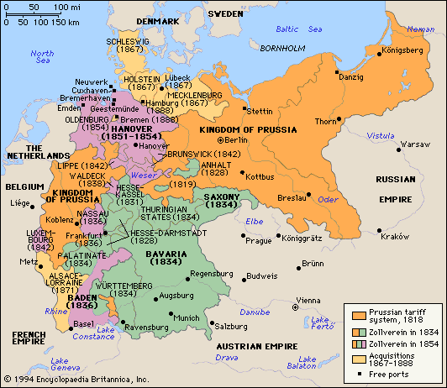
Ida's family had been in America nearly 150 years before her birth with many of them migrating to the American Colonies in the early 1700's. The Grays were actually of German descent with the original name spelled most commonly as Grau. Germany did not exist as a nation at that time and the area was divided into many small kingdoms or principalities. Many of her progenitors lived in or near the Palatine region around the middle Rhine.
The winter of 1709 was extremely harsh in the Palatine.. It was so cold that birds froze in mid-air and livestock, orchards and vineyards were killed. The terrible conditions, combined with political unrest and religious persecution, caused a mass exodus from the countryside along the Middle Rhine.
The "Poor Palatines" were some 13,000 Germans who migrated to England between May and November 1709. Their arrival in England, and the inability of the British Government to integrate them, caused a highly politicized debate over the merits of immigration. The English tried to settle them in England, Ireland and the Colonies.
The English transported nearly 3,000 German Palatines in ten ships to New York in 1710. Many of them were first assigned to work camps along the Hudson River to work off their passage. About 850 families settled in the Hudson River Valley, Later additional Palatine Germans settled along the Mohawk River for several miles, founding towns such as Palatine Bridge, and in the Schoharie Valley.
Ida's ancestors were very likely among these immigrants, settling in New Jersey, and along the Hudson River and Schoharie Valley. Many of them were Roman Catholic, as was Ida.
Ida told her children that she could "trace her lineage back in an unbroken line to the time of the Norman Conquest and beyond for her forbears came to England with the conquering William." Unfortunately, that pedigree was lost, but it was likely her mother's Hilton line to which she referred. In 1066, the English monarch died without any sons, so his royal relatives from Norway and France invaded the country, each claiming kingship. William the Conqueror from Normandy on the French Coast successfully defeated his cousins, took over the monarchy, and settled his countrymen on land confiscated from the English nobles. Ida's ancestors could have been in the invading Norman army or part of the tenants brought across the English Channel.
Ida's Early Years
William E. Gray, Ida's father, was born in 1817 in Guilderland, Albany County, New York. He married Ann Shoudy and they were the parents of six children: George, Margaret, Catharine, Amelia, Milo and Alfred. The children were all born in Albany County. Margaret died there when she was about four years old. By 1850, the family was living in Duanesburg, Schenectady, New York, where William farmed. The 1855 State Census shows the family living in Schenectady City, Ward 1. William's wife was named as Ann, but her birthdate differs from the Ann listed in the 1850 census, indicating that Ann Shoudy had died prior to the census and William had married Gertrude Ann Hilton who is listed in the records as Ann, Gertrude and Getty or Gitty Ann. William and Gertrude were inn keepers and lived in a brick home which was valued at $2500. Five children were born to William and Getty Ann: Helen (apparently listed as Hester in some of the census records), James, Ida (born 1859), William R. and Edwin. The family shortly returned to Guilderland, about 12 miles from Duanesburg and Schenectady, where William took up farming again. The 1860 agricultural census gives an interesting insight into William's life. He owned 43 improved acres and 5 unimproved acres. His cash value was $3000 with farm equipment valued at $200. He owned three horses, three milch (milk) cows, and one swine and had stored nearly 400 bushel of grains.
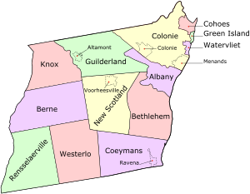
William and Getty were living in Guilderland when the 1865 State Census was taken but moved shortly after that to Macon County, Missouri. There is no record of why, when or how the family made the move. Unfortunately, Getty died there on 13 October 1867. She was only thirty nine years old. William was left with five young children ranging in age from 13 to two years old. Ida would have been eight. William returned home to Guilderland.
Sometime before 1875, William married Hannah Eliza Kniskern. Hannah 's life experiences were very similar to William's. Her parents were also of German descent and her ancestors had come early to America. She had been born and raised in the Pennsylvania Dutch area of New York state. Hannah married Lafayette Emery and they moved to Wisconsin where Lafayette worked as a wheelwright (one who repaired wooden wheels). He contracted yellow fever and died in 1853 at the age of 37, leaving Hannah with three young sons. She returned to New York where she married Daniel Van Valkenburg. They were the parents of three children, one of whom died in childhood. The family moved to Missouri where they lived during the trying Civil War years. Daniel's health was poor and Hannah had to take most of the responsibility for providing for the family. Her oldest son left home at a young age and the youngest son stayed with his Emery grandparents, leaving young Eugene Emery to help her with the family responsibilities. When she and Daniel returned home to New York, Eugene headed west with a mule freight train, eventually ending up as a cowboy/ranch hand in Nevada.
Daniel Van Valkenburg died about the same time as Gertrude Gray. William and Hannah married and combined their families, with the 1870 census showing the Gray and Van Valkenburg children living in the family home.
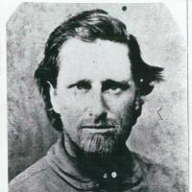
Eugene visited his mother in New York several times. The family story is that he returned to New York after bringing a herd of about 1500 wild horses from Nevada to sell to the army in Nebraska. His mother and William had recently married and Eugene was very taken by William's fifteen year old daughter, Ida. Eugene was about 15 years older than Ida and she already had a beau so he returned to his work in Nevada. He wrote that he returned to New York to visit because he had "found a girl."
By 1880, the family had moved a few miles to Knox where the agricultural census showed that he owned 70 acres of tilled ground 6 acres of orchards or meadows and 10 acres of woodlands. His property was valued at $3000 with $150 worth of implements and livestock which included 4 horses valued at $340. He had made $10 of improvements in the previous year, used no fertilizer and had paid no wages during the year. The estimated value of his farm production was $500.

William died 23 April 1884 and was buried in the Prospect Hill Cemetery in Guilderland, Albany, New York, where many of his family was buried. Hannah was again left with the care of her family. William's will provided his wife Hannah with $500 and a black mare as well as a buggy and harness. The older children received $25 each, indicating that they had already received money from their father. William wrote "I give, devise and bequeath to my daughter Ida E. Gray the sume of 500 dollars and one cow and (?) sheep, the money to be paid to my daughter Ida E. Gray four years after my death." Ida's younger brothers, Will and Edwin were to divide the remainder of William's estate.
The 1880 census shows Ida and her brother James living in the household of William and Martha Chadwick in Duanesburg, Schenectady, New York. James was a farm hand and Ida who was 19 or 20 was employed as a servant. Aunt Nell said that her mother served as a "housekeeper for the Spencer family on their Clifton estate in the suburbs of Albany, New York". Ida was well educated and loved to read. The Spencers apparently treated Ida very kindly. It was probably in their employ that Ida gained her love of books and her "appreciation of the good things of life." Losing her mother at such a young age and being raised by a farmer and a step-mother who had lived most of her life on the frontier would likely not have given Ida a lot of opportunities for schooling and culture. Dorothy Clark has some poetry books that belonged to Ida. Inscriptions in the front cover show that they were gifts from the children, Charles and Louise Spencer. Several of the poems are marked to show them as Ida’s favorites. At some point, she broke her nose while ice skating and was self conscious about the hump the injury had left on her nose.

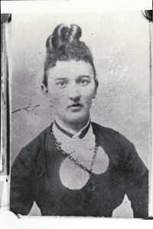
Family tradition holds that Ida was in love with one of the Spencer boys but because of her social position, a relationship was not possible. After her father's death, Ida had been given the responsibility of caring for her step-mother, Hannah. For whatever reason, Hannah, Ida and a friend, possibly Louise Bebee, left New York and traveled to Nebraska. Hannah's son, Eugene, had trailed another herd of horses from Nevada to Nebraska but had been unable to sell the mustangs. Someone traded him a ranch for the horses and he was living in Nebraska. His brother, Mark, and half brother, Dan Van Valkenberg were also in the area. Dan married Louise and Eugene and Ida were married at Douglas, Converse, Wyoming, near Fort Fetterman, which was listed as Eugene's place of residence. They were married on June 17, 1887, nearly a year after the women came to Nebraska. Their daughter Helen wrote that Eugene would often tease Ida saying "I didn't come to you, you came to me." When I questioned Aunt Merle about the story, she said Ida probably came west and married Eugene ‘because she had no where else to go.”

Years later, Charles Spencer stopped at the Emery home to visit Idaho while driving to California. She was very reluctant to have him come because the years on the frontier had taken their toll on her health and her looks. Charles was very polite and the visit seemed to be a good one.

It isn't clear why the family was in Wyoming since Eugene's ranch was apparently in Nebraska and Ida and Eugene moved to North Platte, Lincoln, Nebraska, nearly three hundred miles from Douglas, shortly after their marriage. Their first daughter, Louise was born in North Platte. Ida apparently named her after her friend, Louise Spencer. When Lou was about six weeks old, Eugene gave his place to Dan and Louise. Eugene, Ida, Louise and his mother Hannah started for Idaho.
The family did not take the train which had been crossing the continent for nearly twenty years but instead Eugene purchased a wagon and team to transport their household goods The long trip was likely of little consequence to Eugene and his mother Hannah since they was used to traveling long distances by horse and wagon but it must have been difficult for Ida and her newborn daughter.

My dad went back to bring Mom and he picked her up somewhere in Wyoming to bring her to Idaho. He drove Eliza Jane (a very gentle little brown mare) and something else with her on a spring wagon. Anyway, while they were on their way out here, my oldest sister was born. They named her Louise. On the trail before they got here Eliza Jane (had a colt.) They laid over a few days and finally loaded the colt in the back of the buggy and continued on the way to Goose Creek.

Mom told me…she never did talk much about it…she said that on that trip when they was coming back here through Wyoming she walked most of the way through there…And she said she never saw such desolation in her life. She said there was just nothing. Just distance all the time…

Jim Householder was living in Eugene’s cabin on Goose Creek. When he heard that Eugene had married and was bringing his family back to Idaho, Jim built another cabin further up the creek so that Eugene would have a home for his wife. Life in Goose Creek had to have been a culture shock for Ida as she had lived most of her life in or near New York towns. She did her best to make her home and family comfortable. Gene remembered:
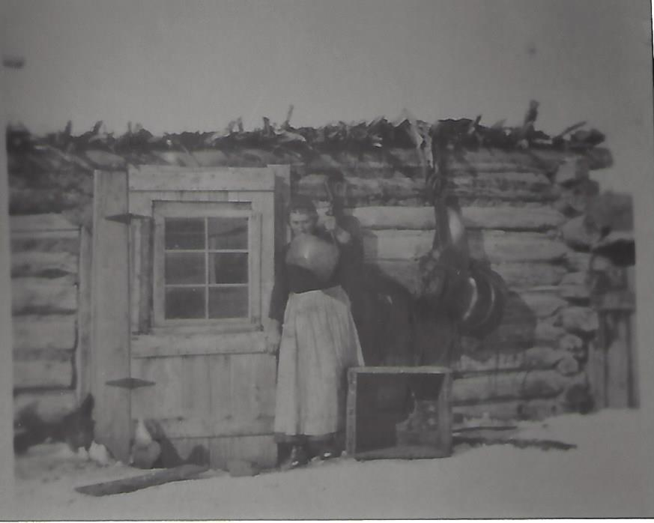
The house was built into the hill and there were two rooms. Behind this house was a cellar taken off into the hill with a door from the house into the cellar. That was our main home.

Dad built two little rooms onto the buildings there. One was used for a front room and the other for a bedroom. Mom fixed the front room up really nice and everything. Had the walls all covered with some kind of material.

Philip remembered that there were two houses---one on each side of the road and both having two rooms. The room “east of the kitchen was what we called the Blue room which was lined with blue cloth.” A room in the other house had a fireplace and was lined with red material. They called it the Red room and it was used as a bunk house. The other room was used for storage.

Merle described the house in a little more detail from her interviews with Gene and Nell. She said that the house was a two room log cabin with a cellar behind in the hill. The cabin had a sod room and packed dirt floors. Merle said that Ida would wet down the dirt, smooth it and then draw patterns (probably a floral design) to resemble a carpet. A large fireplace built of sandstone rock stood in the northeast corner. There were two windows and doors out on the south and east. Another door led into the cellar.
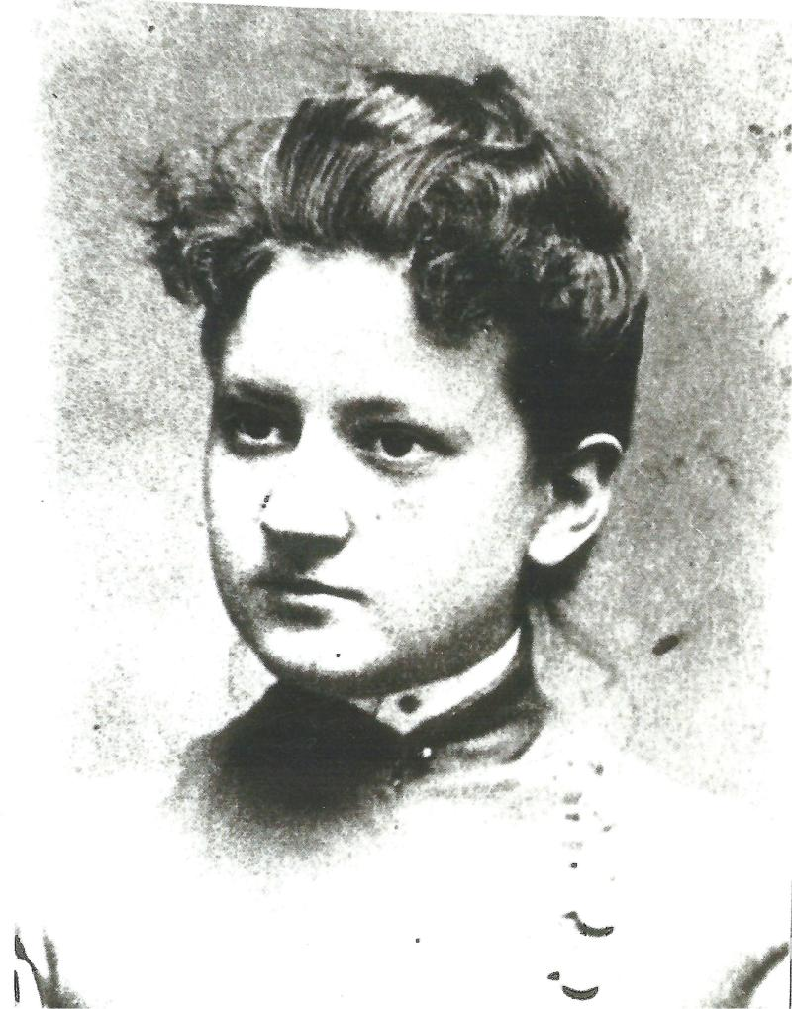
They planted a big garden, growing strawberries and raspberries along with many different varieties of vegetables. A big patch of alfalfa was just across from the house. Grandpa built a wire net fence around the yard. A stable, corrals and other outbuildings were nearby.

Her children remembered that the women living on Goose Creek were taken with the way she braided her hair and had her teach them how to do their hair. On occasion, she would invite the ladies to her home for tea. Gene remembered:

My mother as a girl worked for a family in New York. Their name was Spencer. She was married when she was 27 years old and came out to this country and brought a lot of books and things they had made as presents to her. As time went on Mom added to these books and other things. She used to tell us kids things that had happened and things that was going to happen. She also told about the book Twenty Leagues Under the Sea that there was going to be boats that would travel under water and things like that. Which we couldn’t believe then but which has happened since. I remember Mom being left alone with us kids and our nearest neighbor was an old fellow named James Divine, an old bachelor.

Ida soon picked up the skills she needed to survive in Goose Creek.

I remember one morning I looked out and there were a couple of coyotes between the house and chicken coop. I remember Mom getting the gun which she could handle pretty good and shooting at the coyotes.

She also learned to milk and feed the cows, make cheese, care for the chickens and pigs, help butcher the animals needed for food, haul water and wash clothes on a wash board, make her family’s clothing, and dozens of other skills. Philip remembered that after the older children had moved back to Oakley for school, he, Jim and Ned would be up Goose Creek with their folks. “Dad would hook up the wagon and go down to Trapper creek to an orchard owned by Mr. Devine and Mr. Shaw to gather apples and other fruits for winter. Us three kids would have a good time picking the big sweet apples. Then we would get home after dark.” Merle said that Ida saved her egg money and bought a fancy piano. When you pushed a pedal with your foot, the piano would play different sounds including a banjo and stringed instruments.

Ida had her hands full caring for the children in addition to her other responsibilities. Eugene and Ida were the parents of nine children: Louise (Lou, born 1888 in Nebraska); Christine (Kit, born 1890); Eugene (Gene, born 1891); William (Will, born 1894); Helen (Nell, born 1896); Edwin Gray (Ned, born 1898); and the triplets, James Hilton, (Jim), Philip (Tad or Terp) and George. It is easy to see where all of the children but Kit got their names. Lou after Louise Spencer whose parents had employed Ida; Gene after his father; Will after Ida’s father; Helen after Ida’s sister; Edwin after Ida’s brother; James Hilton after her brother; Philip after her father and perhaps Phil Shaw, a close friend; and George after her brother or George Washington, since the triplets were born on President’s Day. Aunt Nell wrote that Ida delivered Aunt Kris (Aunt Kit as our family called her) with only Hannah's help.

Ida's days were busy with both household and outside chores, but she still spent time nurturing and caring for her young children. Gene remembered:

The first things that I can remember we were in the old house. My brother (Will, two years younger) and I were playing on the floor. When we were playing on the floor, mother gave my brother some blocks to play with and I wanted them. I couldn’t have them so I started bawling. She hunted a can that had paint in and gave it to me. While dad was working there he needed it so he took it away from me and I bawled again. It went on from there. (The can contained slate and Eugene was making a blackboard for the older children and needed the paint.)

Dad built a cradle just big enough to hold the four of us kids, which were there at that time. We used to get in that and think it was singing. We made plenty of noise anyway and mom to keep us quiet used to make sugar tits for us….Mom made these sugar tits by taking a small cloth and putting a spoonful of sugar in and making a kind of little ball out of it and a place to hold to it behind the ball and we’d suck on it until the sugar was all gone.
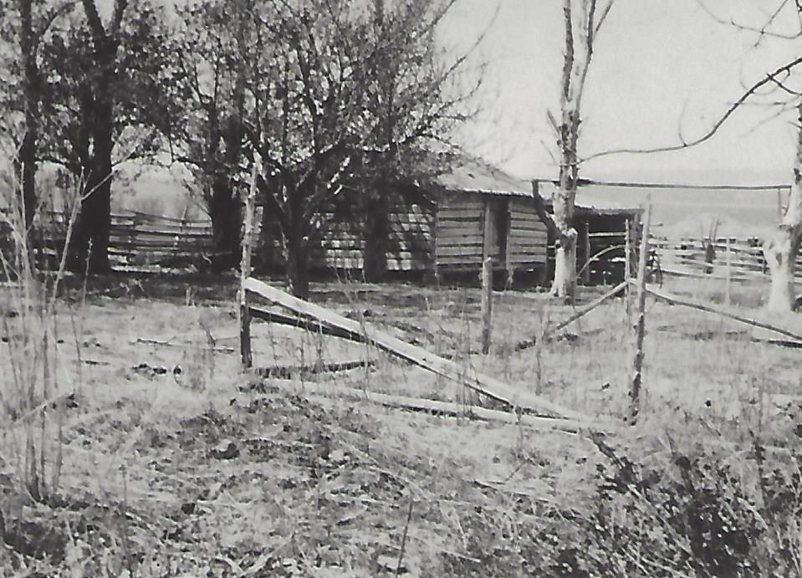
One year a cloud burst in the hills resulted in a flash flood on Emery Creek, where the little cabin was situated. Ida was home alone with the children and could hear the sound of water rushing down the canyon. She lifted the children up onto the kitchen table. When the water was about a foot deep, she opened the swing window which opened out onto the hillside and lifted each child out, instructing them to “get up the hill.”

The rushing water washed out the fences, corrals, strawberry and raspberry patches and the garden. It picked up two full grown pigs and washed them down Goose Creek. Gene remembered “We saw them pigs when they went out of there on that flood....That night we was out there, they was spotted pigs, black and white, and one of those pigs come back and we watched it swim Goose Creek. You couldn’t do a thing with that piece of ground after that flood”

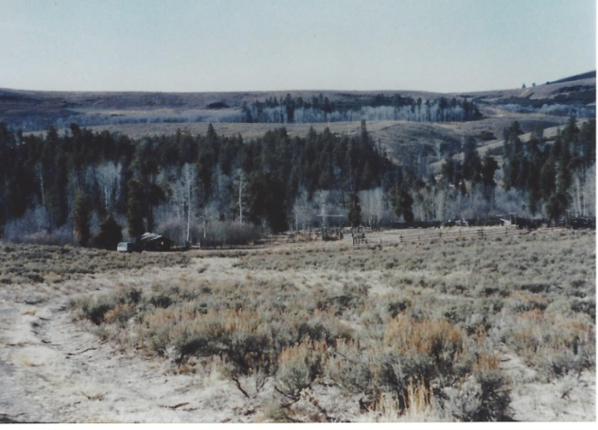
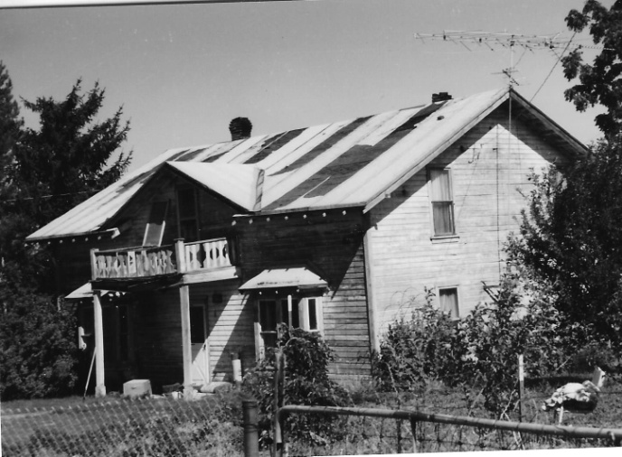
The family moved to a cabin owned by Ida’s brother, Will Gray, and lived there for many years. About 1896, they bought a house just below the Oakley Dam and moved there during the winter so the children could attend school in Oakley. In 1912 Eugene and Ida hired Cap Whittle and Axel Erickson to build a two story frame house by the Oakley Reservoir. Gene said that he and his mother had gone to their friend and neighbor, James Divine, to borrow $800 for the house. Someone always had to be at the ranch for chores and to tend the animals and put up the meadow hay, so their lives were divided between Oakley and Goose Creek. During the winter months, Eugene and the other ranchers were frequently gone from home as they herded the cattle and the horses. Eugene and his boys were busy most of the summer as they put up most of the hay on Goose Creek, moving from ranch to ranch until the harvest was completed. Aunt Nell seemed to have been closer to her Dad than she was to her mother. She remembered going up with her Dad to Goose Creek during the summer as young as five or six.

James Divine and Phil Shaw and his family were close friends of the Emery family. They lived on Goose Creek and the men spent a lot of time working together and visiting. Gene and Will were a lot of help to their parents and often did a man’s work. The boys went on the roundups and cattle drives. The ranchers ran their cattle together on the range. They would have a “rodeer” and gather the cattle, branding the cattle or gathering them for market depending on the time of year. The cabin and corrals at Piney were one of the main places the ranchers would work their cattle. The two boys accompanied their father on a cattle drive to the train station in Tecona, Nevada. It was the first train that the boys had seen and they were fascinated.

The Goose Creek ranchers also gathered up the horses which were running loose on the range. By now, many of the horses had been branded and belonged to the various ranchers. The horse roundup was an exciting time. Philip remembered coming up for the roundup with his Mother.

As far back as I can rember was an old covered wagon drove by Ross Rytting who brought Mother up the creek and I came along. The wagon was loaded with chickens and geese. We came up the old Goose creek road which is now covered by water of the dam. I must have been three or four years old at this time. We reached the ranch ok, for I rember how long the road seemed, and how glad the rest of the folks were to see us. It must have been the later part of April for school was out. There were to houses with the road between them. As we arrived the kids came out of one like a bunch of Indians. They were shure glad to see us arrive. Dad was home so he went and helped Ross unharness the team of gray horses old Fred and Steel, and turned them in the corell. Then came back to finish dinner, which had been cooked by Lou and Kit. So it was a famley reunion. The kids were all home, Lou, Kit, Gene, Will, Nell, Ned and Jim. They gathered horses. They would bring them to the corell and cut out the ones that belonged to some one else and keep the ones that they wanted to herd. There would be a lot more men come in with the horses for they would meet out on the range some where and bunch all the horses and bring home to the corell to get their own horses….Gene and Will would herd the horses with Dads help for about a month then they would be turned loose to go back to their range after the colts were branded. Dad would take me behind his saddle and go after horses. The more I howl, the faster he would go.

Ida’s brother, Will, had followed her to Goose Creek and had a ranch near theirs. Gene and Will often worked for Uncle Will. Gene felt that he was a hard task master and didn’t much care for him. Ida and her brother would sometimes have words when she felt he wasn’t treating her family properly.

Challenges of Life
On 22 February 1901, President’s Day, Ida gave birth to triplets. Philip weighed three pounds and Jim and George each weighed two and a half pounds for a total of eight pounds. It is hard to imagine how the family could have kept three tiny premature babies alive. The babies were probably near full term but extremely small. Even if they were fully developed, it is an amazing thing that the babies lived. Philip said, “There was no doctor handy so Mrs. Alford Elison and Mrs. Swanty Nelson took care of Mother until he came.’ They kept the babies warm by wrapping them warmly and putting them behind the wood stove and feeding them with an eye dropper. Triplets were such a novelty that the event was covered by the newspapers. “Gifts of baby clothing came from ‘caring people’ unknown to them; some from relatives and acquaintances where they had lived in New York.”. Guina, Gene’s wife, said that visitors and neighbors lined up in the dooryard to see the babies. The neighbor ladies came in frequently to help care for the tiny infants.

George died of pneumonia when he was six weeks old. Eugene was gone when he died, leaving Ida to cope alone with her grief. Gene said that something changed in her after George’s death. She seems to have struggled with depression and grief the rest of her life.

In January of 1907, tragedy struck the Emery family again. When Philip was just six years old, he became very ill.

When I was five or six, I had pneumonia. I remember well the night before I took sick. Ned, Jim and I were playing on the haystack and I fell of it. They had to go get Mother to come carry me to the house. I remember Dad and Will coming into the room to see me. That was the last time I remember Will. Dad sent him and Ned up to Uncle Wills to feed cattle for him…They had Dr. Nielson for me but he said there was no chance for me to live. But Fred Bach had just come from town and told Dad a new Doctor had just arrived in town and that he would get him for me. So Fred Bach brought Dr. Oldham up the creek. I was his first patient when he landed in Oakley….

Gene continued the story.

There before midnight in drives Doctor Olden… It seems like Fred Bach was with him that trip. He come in there and examined Philip and…I heard him tell the folks, he wouldn’t give them any answer whether he was going to make it or not.
He had a heck of a temperature and he said that if they couldn’t break that temperature before morning he didn’t have much of a chance. So he stayed all night….and the fever broke.

The next morning, the family was standing out in the front yard, relieved that Philip’s life had been spared. Then someone rode in to tell them that Will had been killed. It was the 29th of January 1907. Will had just turned thirteen. Ida, weak from the ordeal with Philip, fainted.

Will and Ned had been sent by Uncle Will to skin a cow that had died out on the range. As Will was cutting off the hide, a coyote kept bothering the boys. Will reached for his rifle and began pulling it closer when the gun discharged, killing him. Eight year old Ned was miles from home, alone with his dying brother. He made it to the Wine Cup ranch where his older sister, Kit Bedke, and her family lived. Charley Parker, a neighbor, was visiting the Bedkes and he hitched a team to their wagon and went to get Will and bring him home. Kit and Frank were likely the ones who went to tell the family of the accident.

Will’s loss was keenly felt by the family. Nell remembered that Will was red-headed with freckles, large for his age, and full of fun. He “would tease his mother by kissing and hugging her until she would squeal.”
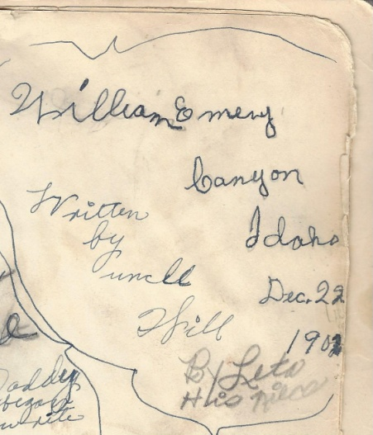
The story about Will is a tender one for the family. He is buried in the Oakley Cemetery by his parents, Grandmother Hannah, and brothers Philip and George. We always heard that the gun discharged because a piece of sage brush caught the trigger as Will pulled it towards him. Many years later, one of Merle’s boys took the rifle to a gun shop to have it repaired. The gunsmith refused to try to repair the gun because the hammer did not lock properly. The gunsmith felt that the gun wasn’t safe to use. I have a copy of a Mother Goose book given to Will when he was eight years old. Will wrote his name and the date in the front of his book.

Philip was still very ill. There were no antibiotics, but Doctor Oldham would mix a special tonic for the little boy. Every afternoon, Gene, who was just fourteen, would ride the fifteen or so miles down Goose Creek to Oakley with a report on Philip’s condition and wait for the doctor to mix the prescription. Then he would ride home in the dark. It was very frightening for the young teenager. A cougar had been spotted in the area and jumped a rider, leaving claw marks across the back of his saddle. Gene was terrified that the cougar might attack him. Eugene was about sixty three years old and so depended upon his oldest son for help.

Philip wrote:
It wasn’t long after this I was taken to town. Mother made me a suit out of red flannel. It covered me from head to toes. I can still hear Ned making fun of me as I was put in back of the white top buggy for being such a sissy, but I was too sick to care. I was put in a bed so it was not such a bad trip to town. I remember Dad carrying me into the house. Dr. Oldham was talking to Mother telling her I would be all right but it would be a long time before I got stout. Mrs. Elison and Mrs. Nelson were good neighbors for one of them were up to help take care of me most every day.

It was along about this time or later when Mother took down with typhoid fever, and Mrs. Harrison Shaw took me and Jim up trapper creek to stay with her. We were there all that winter and most of the next summer, but they would take us down to see Mother and the rest of the famley about every two weeks….From then on Mrs. Shaws was like home so we would go up and stay most every summer for a week or two with her.

Gene wrote:

I’d like to say a few things about my mother. She was a real mother to us kids. Not only to us kids but to other people. She never turned anybody away without a meal if they would eat or a place to stay nights. I remember a couple came down there. Name was Walt Gamble and his wife. Remember mother fixing them a meal feeding them strawberries and cream. Looking after them. Getting up they thanked her when the left and they made mother feel happier.

And there were three Negroes that came around one time. It was night. They had no place to go. Mom made sure they had a place to stay the night.

When Eugene was drafted into the Army during World War I, he ”never missed a week on this side of the pond (before being shipped out to France) getting a letter from mother….not once.” One of the poems marked in her book was ‘In Flander’s Field”, written about the young men killed in the war and buried under the field of poppies. She must have worried much about her young soldier son.

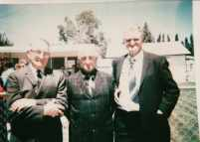
Ida valued education and made sure that her children attended school as much as possible. It was hard for her sons because Uncle Will often needed help with cattle and the older boys would have to go and help out, frequently missing school. They still had good reading, writing and arithmetic skills.

Philip and Jim’s schooling had a rough start. Philip and Jim had just started the first grade. Philip was running after a cat and hit a barbed wire fence, cutting his face badly. Ida had to keep him home to tend the wound and he was so bored that she kept Jim out of school to keep him company.

Ida made sure that Lou, Kit and Nell finished their schooling in Oakley and went on to the Albion State Normal to receive their teaching certificates. Aunt Nell told her daughter that "she was very ambitious for her children and denied herself a great deal to send her girls to school (the Albion Normal School). I guess she would have sent the boys, too, but they didn't want to go." Even Philip attended the Normal. He was just getting settled in when the influenza epidemic hit and the school was closed and the students sent home. He didn't return to school.

The Later Years

Mrs. Elison gave Ida a large loom and Ida wove room sized carpets that she sold in the community. Granddaughter Margaret Lindsley wrote:

During long summer evenings and longer winter months, she operated a noisy loom, turning out miles of rug runners for a commercial carpet company. Part of the income was used to buy books and as she added to the books she had brought west with her from New York she built an impressive library. She also gave books to her children each Christmas and some, such as the complete works of Dickens, Scott, various poets and Gibbons History of the Romans are still treasured - and read- family heirlooms.

People would bring their old rags and clothes to her and she would tear them into strips about an inch wide and then sew them together with her treadle sewing machine. Then Ida would roll the various colors and patterns into big balls. She had a “spinning wheel” that she used to make the warp for the rugs. Ida had an artistic eye and her rugs were beautiful. Eugene indicated that some of the money went to pay for the house at the Oakley Dam.

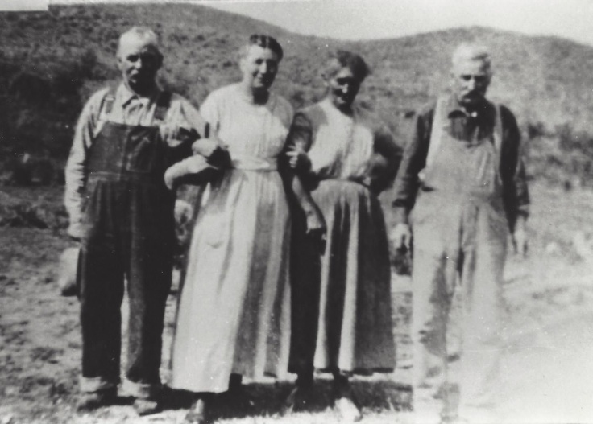
As the children left home and Ida began to suffer the effects of aging, her depression seemed to worsen. Nell's daughter wrote that Ida tried to get Eugene to move the family to Salem, Oregon, "and was very disappointed when they didn't for she felt the cultural and educational facilities there woudl approach her high standards. From then on and especially after the menopause, she grew extremely introverted and became somewhat psychotic as did many pioneer women under the stress of frontier life."

Eugene and Ida had always split their time between the home in Oakley and the ranch at Goose Creek. Gradually Eugene quit coming to the house at the Dam and Ida lived there alone. Gene remembered, “Mother would weave day after day after day. She would sit there all day long and maybe all she would do is get up and get her a cup of tea.” Her health began to deteriorate. She became ill and Kit took Ida into her home so she could care for her. Ida developed huge bedsores and her skin fell off in huge patches. Kit would tenderly treat the open wounds with zinc salve, but nothing helped.

Granddaughter ))))))) was five years old at the time. She wrote:

I can remember her as a little dumpy old lady with the blackest eyes who said "I told you so" after I ate too many currants and was sick. If I were to know her now I would probably understand and like her but she was too abrupt and cold to endear herself to the five year old I was then. She suffered dreadfully before she died and even I felt sorry for her, young as I was and ran errands for her cheerfully.

“When Grandpa got word that she was ill he came to her. She said to him, “Oh, Gene, I knew you would come!” Grandpa replied, “All you ever had to do was ask”. Ida died 16 August 1925. and was buried next to her sons and mother-in-law in the family plot in the Oakley Cemetery. She was 66 years old. Her death certificate gave the case of death as malnutrition, which hurt Aunt Kit. She had tried hard to help her mother eat and regain her strength, but had been unsuccessful.

Musings
I have thought a lot about Ida as I worked on this history. Some of the stories I have read seemed unflattering to Ida while others were more positive. Aunt Nell's daughter described her as "dark-eyed with lots of heavy black hair, she was proud and introverted, interested in culture and the good things of life and wretched over having to bring her children up so far from the genteel traditions she held in high esteem". She also wrote that Ida was a "True Victorian" and that she wasn't "demonstrative even with her children and for affection and good natured understanding they turned to their father." My Grandpa Eugene remembered his mother as kind and caring, taking care of the children and anyone who came to their home. He, however, struggled in his relationship with father. I wonder if the two accounts seem to conflict because of the family dynamics. Ida had the responsibility of teaching and disciplining Nell while Eugene was under his father's supervision. We don't take well to being told what to do, but like to make sure that others do things right. As you read this history and those written by Aunt Nell, Aunt Merle and others, you can recognize the strengths and the challenges of the personalities of each family member. It may be that the traits our family laughingly refers to as the "Emery in us" actually come from our "Grau" ancestors instead.
Ida's life was challenging.. Most of her early years were spent in the larger towns of Albany and Schenectady and as she worked for the Spencer family, she was exposed to literature and a more genteel culture. She struggled to provide those good things for her family, buying a piano and not only building a library of the classics but reading and telling the stories to her children. At the same time, she had to learn the skills of a frontier woman, including having to milk a cow, cook on a wood stove, and sew and mend for nine children. Her life was dedicated to making things better for her family.
She knew loss---with the death of her mother when she was only eight years old, burying a tiny baby boy that she had kept alive on the warmer of her wood burning stove, and the tragic death of her fun loving Will at the same time she was afraid of losing little Tad. She struggled with the introversion and depression that many of us also have to deal with.
She wasn't perfect, but she was a good woman and she raised a good family. We owe her a debt of gratitude.
.
Janis Clark Durfee
durffam@atcnet.net
Written December 2016

familysearch.org Map: sieu.com
German Palatines. Wikipedia. Accessed 4 December 2016. (Eugene Emery's ancestors lived in Schoharie County).
Merle Emery Feriante. History of Eugene Emery Jr. p.
Partial History by Margaret Hawkes Lindsley, daughter of Helen (Nell) Emery Hawkes. In possession of Janis Clark Durfee.
//www.britannica.com/event/Norman-Conquest. Accessed 9 December 2016.
Familysearch.org, 1855 New York Census, Schenectady, Schenectady City, Ward !.
1860 U.S. Agricultural Census. Ancestry.com.
Records of Merle E. Feriante, Verna E. Page, and Helen Hawkes. Census and death/burial records are not available to verify this information, but her mother's death information had to have been passed from Ida to her children.
Margaret Hawkes Lindsley. Grandma Emery's Cookbook. Story also told to Janis Clark Durfee by Merle Emery Feriante. 2015.
The Story of the Life of Eugene Emery Sr. as told by himself while in good health up till the year of 88.
William E. Gray Will. ancestry.com. Digital copy in possession of Janis C. Durfee. 2016 Headstone: Find a Grave. Prospect Hills Cemetery, Guilderland, Albany, New York. Accessed 2016.
Grandma Emery's Cookbook.
Partial History of Margaret Hawkes.
Janis Clark Durfee. Eugene and Ida Estella Gray Emery. p. 23.
Western States Marriage Index for Eugene and Ida.
Merle Emery Feriante. History of Eugene Emery Senior. pp. 62-63.
Conversation with Merle Feriante. 2015.
Ibid. p. 63.
Gene. . P. 2
Gene.
Autobiography of Philip Emery, son of Eugene and Ida Emery., P. 1. Picture: Ida standing in front of the house on Goose Creek.
Gene.
Conversation with Merle E. Feriante, December 17, 2014.
Gene.
Eugene Jr. p. 2 Picture: Ida Estella Gray.
Philip, page 2.
Gene. p. 1
Gene, Picture: House on the Will Gray Place where the family lived after the flood.
Eugene Sr., p. 68, Gene, p. 67. Dorothy Emery Clark. Memories of Eugene and Ida Emery.
Pictures: House by the Oakley Reservoir. Road into the cabin and corrals at Piney, Nevada
Philip, page 1.
Dorothy Emery Clark. Memories of Eugene and Ida Emery.
Gene. Page 63.
Philip, P. 2
Gene, P. 34.
Gene. P. 64.
Gene, P. 72.
Eugene p. 64-65.
Philip, page 1.
Philip, Page 1 . Cover page of Will’s Mother Goose Book.
Gene, P. 23.
Partial History of Ida.
Philip,. P. 3. Picture: Eugene, Jim and Philip.
Margaret Hawkes Lindsley. Gifts from the Goddess. "Grandma Emery's Cookbook." p. 25.
Partial History of _______.
Gene, p. 27. Picture: Eugene's brother Dick and wife, Sarah, Ida and Eugene.
Partial History of ______.
Dorothy Clark, Memories of Eugene and Ida Emery. Picture: Eugene's brother, Dick, his wife Sarah, Ida and Eugene. Dick and his Family were visiting Eugene and Ida.

